Ilkley Quaker Meeting House
Queen’s Road, Ilkley, LS29 9QJ
Welcomes the return of
Plain Quakers
in their new thought provoking drama
‘For Conscience Sake’
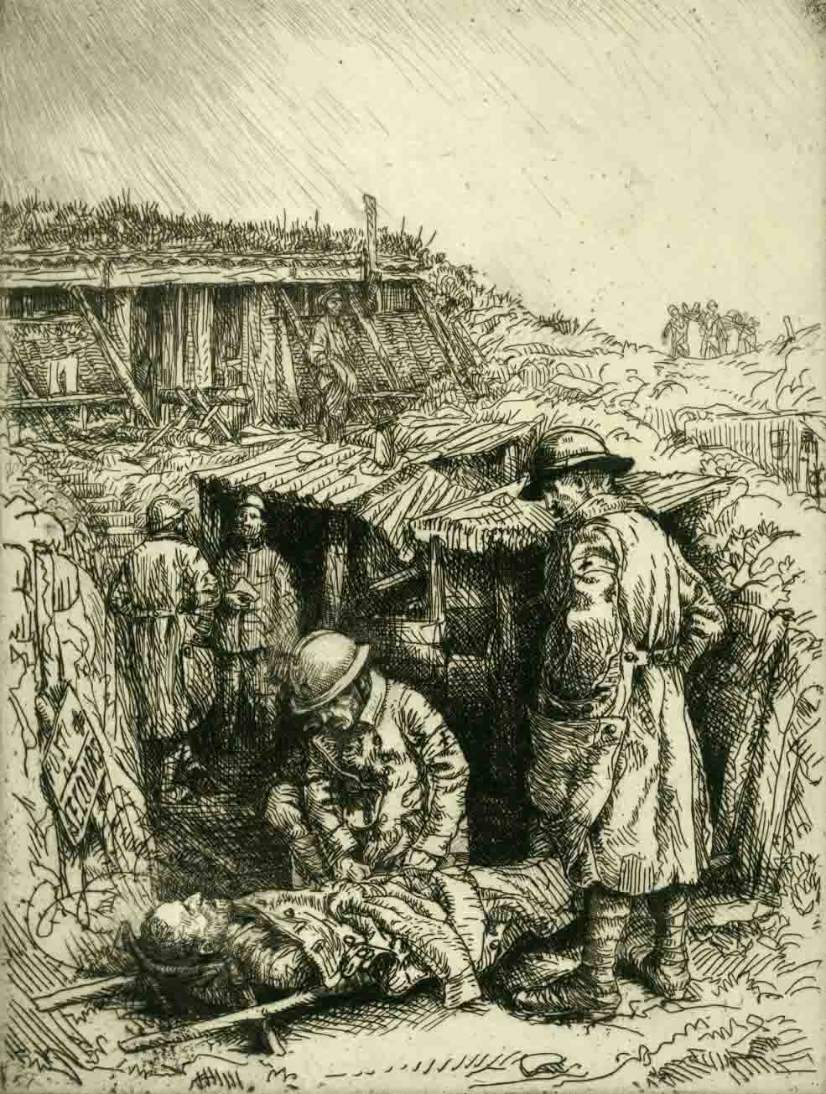
Conscientious Objection in WW1
and the culture of militarism today
Friday 9th October 7.30 pm
All welcome Refreshments
Entry free: donations invited for Peace Work

