Ecumenical Accompaniers – role description  and skills and qualities needed | 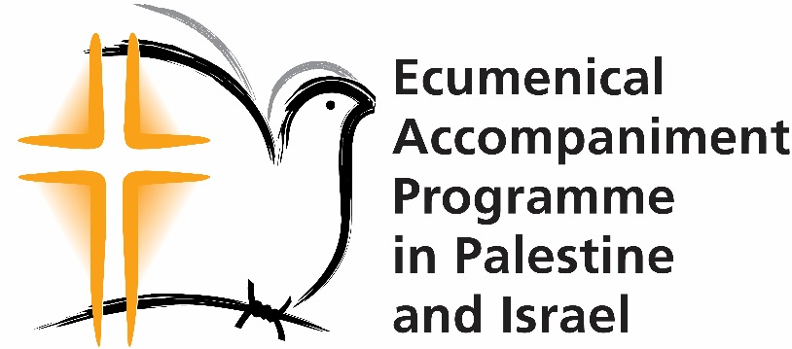

Ecumenical Accompaniers are human rights monitors. We call them EAs for short.

What EAs do

- Being an EA begins with doing background reading, which we provide, and completing some assignments.
- Next, there is a two-week preparation period in the UK.
- EAs then spend 3 months in Palestine, living and working in small international teams in the West Bank. While they are there, they:
- witness and report violations of human rights and international humanitarian law.
- offer protection through nonviolent presence, which can sometimes deter violence and human rights abuses.
- support nonviolent resistance by Palestinians and Israelis.
- stand in solidarity with all those struggling nonviolently to end the occupation and the conflict.
- witness and share in daily life under military occupation.
- build relationships with Palestinians and Israelis, which will further the programme’s work, and learn about a variety of Israeli and Palestinian viewpoints.
- report frequently and extensively about their activities, and on incidents of violence and human rights abuses.
- establish and maintain contact with the media at home.
- write about the stories of people they meet for publication on our website, social media and elsewhere.
- work alongside vulnerable adults and children (requiring a criminal record check).
- After EAs come back from Palestine, there is a two- or three-week rest period, then a four- or five-day Advocacy and Debrief week which allows them to prepare for their advocacy and debrief their time in Palestine.
- EAs then go on to do a minimum of ten public speaking engagements and other advocacy. They fit these around their other commitments.

Inclusion and diversity

EAPPI stands against all forms of discrimination and prejudice, including but not limited to antiblackness, antisemitism, classism, homophobia, islamophobia, racism and sexism, with an understanding that these are often overlapping.

We want to build an inclusive and diverse network of EAs and particularly welcome applications from those usually under-represented as EAs, particularly people from Black communities, People of Colour, and those from disadvantaged socioeconomic backgrounds. Applicants from these groups who meet the minimum requirements for the role (below) are guaranteed an interview.

EAPPI is a church programme but is open to all and there is no requirement to be Christian or involved in a church. We welcome applications from people of all faiths and none.

EAs are not paid but they receive a living allowance for their time in Palestine and their expenses are paid. We recognise that the unpaid nature of the work makes service as an EA very difficult for some people, particularly those with caring responsibilities and those without financial stability. We regret that our current funding does not allow us to change this.

The programme is accessible for some but not all people with disabilities. Safety requirements mean it must be possible to correct your hearing to a level which allows you to hear clearly in crowded and noisy group situations, and if needed you must be able to run away. Unfortunately, due to the environments EAs work in it is not possible for wheelchair users to serve. The work is physically and emotionally demanding and may involve standing for long periods, walking long distances, and witnessing distressing scenes (see ‘Risks and difficulties of the role’ below). If you have a disability and are not sure if the programme would be accessible for you, please contact us to discuss this.

The age range to take part is approximately 25-70 years.

Personal responsibilities

EAs must:
- respect the ecumenical nature of EAPPI as it reflects its Christian heritage, as well as the other faiths you’ll work alongside in Israel and occupied Palestine (I&oP).
- undertake their work in Palestine from an anti-oppressive perspective, including examining their own position and role in relation to their teammates and Palestinians and Israelis they work with.
- undertake their advocacy in Palestine and on their return from an anti-oppressive perspective, including actively standing against antisemitism.
- respect local cultural norms and practices and commit to refraining from engaging in behaviour that could be perceived as provocative or disrespectful.
- conform to EAPPI procedures and methods both in I&oP and in the UK and Ireland as defined in the contract.
- comply with the EAPPI Code of Conduct including an order to evacuate when necessary.
- maintain regular contact and communication with their EAPPI team and the EAPPI Local Programme Coordinator on personal location and activities.
- provide timely and detailed reports on their own and their team’s activities, and on incidents they have observed.
- engage in mandatory programmed sessions for training, briefing and orientation purposes both in the UK and in I&oP.
- act from a focused, nonviolent, peace-seeking personal centre.
- follow the security advice provided by the EAPPI Local Programme Coordinator and local contacts, and refrain from taking unnecessary risks, which would endanger their own or others’ life and health or bring the Programme into disrepute.
- acknowledge the risks inherent in this situation of conflict and take ultimate responsibility for personal safety and security by signing the ‘Statement of Indemnity’.

Experience/skills and qualities needed

Essential experience/skills (these are the minimum requirements used for shortlisting for interview)

- Active involvement in community networks in the UK and/or Ireland. These could be related to your local area, interests, faith, work or any other communities you are connected to.
- Knowledge of and interest in the Middle East region and the conflict in I&oP.
- Experience of living/working in a different cultural context and an understanding of the need for sensitivity to the region’s cultures. This does not mean you have to have lived abroad, as we also value experience of living or working in different cultural contexts in the UK or Ireland.
- Awareness of dynamics of power and privilege and colonialism and how these can impact the work of an international team.
- Experience of being in a non-hierarchical team, working cooperatively, being adaptable and self-motivated and working within specific guidelines.
- Experience in advocacy work, for example, public speaking, lobbying faith leaders and political representative(s), advocating for yourself or others.

Essential qualities (these will be assessed at interview and throughout the preparation period)

- Maturity, psychological stability, flexibility and ability to cope with stressful/critical situations and changing circumstances.
- Willingness to develop relationships with both Palestinians and Israelis and an understanding of why this is crucial to the work.
- A commitment to engage constructively with people in authority and stay calm when provoked.
- A commitment to the principles of peace, nonviolence and reconciliation as a way of life.
- A commitment to actively opposing antisemitism in advocacy for peace and justice in Israel and Palestine.
- Respect for and willingness to participate in a variety of religious ceremonies, and respect towards the church-based character of the programme.
- Strong organizational abilities.

Essential competencies (these will not be used for shortlisting for interview, but if you are appointed and do not have these competencies, you will need to develop them)

- Competence in using mobile phones and laptops including competent use of Microsoft Word, Powerpoint, the internet, email, and a memory stick/flash drive or file sharing app.
- Excellent communication skills in English, both written and spoken, and an ability to report in writing in a clear, accurate and timely manner.

Desirable experience/skills

- Nonviolent direct action and community organising/solidarity work.
- Competence in photography or video.
- Research and reporting on human rights and/or development work.
- Knowledge of Arabic (especially Levantine Arabic) and/or Hebrew.

Support for EAs of Colour

We recognise that EAs of Colour may face particular barriers in their service as an EA, for example encountering racism from EAs in their training group before they travel, and from team members and others they work with while in I&oP. We aim to prevent this to the best of our ability and to support EAs of Colour when it does occur. We are working to incorporate an anti-oppression perspective throughout our training and to support white EAs to understand their own white privilege and to act from a place of awareness of this.

Due to racial profiling at the Israeli border, there is an increased risk that EAs of Colour will experience extended questioning on entry to Israel or difficulties obtaining a visa, or in the worst case, being denied entry and deported. We aim to reduce this risk as much as possible through individual support to EAs of Colour with the process of airport entry. In the worst-case scenario that any EA is denied entry and deported, we would aim to support the EA to find alternative voluntary work if wished.

Risks and difficulties of the role

Please note the following, which will help you decide if this work is for you or not.

- Close family and friends can worry about EAs in Palestine and Israel. Make sure you have their full support.
- EAs live in a conflict zone but have to maintain what call ‘principled impartiality’. This means you must be committed to principles of human rights and international law above any desire to support one side over another.
- Living conditions in occupied Palestine can be simple and special diets may be difficult to maintain.
- EAs are placed in small international teams and have to live and work together under stressful conditions for three months. You will have to share a bedroom with another person and private space is difficult to find.
- EAs who thrive are typically those who are flexible, self-aware, able to ask for help, able to take criticism and advice, and who have a ‘can-do’ approach.
- It is not permitted for EAs to drink alcohol while they are on duty in their placements. This means you will not be able to have an alcoholic drink for extended periods during your service in Palestine and Israel.
- The work is physically demanding. You may stand for long periods of time at checkpoints, walk long distances over rough terrain and get up before dawn for duties.
- In a crisis situation you may have to leave an area very quickly; this means you need to be able to run at full pelt for several minutes over uneven ground.
- Very good hearing is vital for keeping safe. This includes being able to hear clearly in crowded and noisy group situations.
- The work can be emotionally draining and put you under considerable mental stress and you may not have access to your usual support systems and strategies.
- For your own safety it is important to fully disclose health issues. Failure to declare health issues that then prevent you completing your duties may result in you being sent home.
- Access to medical facilities is generally good but varies depending on your placement. Being frank about your health once you have been selected is vital for our colleagues in Jerusalem to place you appropriately.

These issues are raised here not only so that you can consider them for your own safety and security, but also so that you can consider the knock-on effect of these issues on your teammates and the security of the team as a whole, should you be recruited.

Conditions of service

Working hours: A nominal 35 hours per week. However, EAs need to be flexible so that they can respond to the needs of each placement and of the local community. EAs are entitled to the equivalent of one day off per working week (often accumulated and used in a block), but evening and weekend work is often required. EAs need to ensure that adequate time is taken for rest and relaxation throughout their period of service.

Expenses covered:
- Food, travel and phone calls while in Palestine and Israel. This is provided as a cash allowance on a monthly basis.
- Outward and return travel from UK/Ireland to Tel Aviv.
- Travel, accommodation and food for the two-week Preparation period and for the Advocacy and Debriefing week following your three months in Palestine and Israel.

Benefits:
- Accident, travel & medical insurance.
- National Insurance contributions (or equivalent for Irish EAs)
- Financial support for counselling and retreat after return home.

Equipment: All EAs receive a mobile phone for use in I&oP. All EAs will also use laptops, which we can provide.

Candidates who are successful at interview will be expected to complete a medical questionnaire and a criminal record check.

During the two-week residential Preparation period, we work together with EAs to understand if the role is right for them and to support them to become ready to serve in Palestine and Israel. If we and they are sure that the role is right for them, we formally appoint them at the end of this two-week period.

Background to the programme

The Ecumenical Accompaniment Programme in Palestine and Israel (EAPPI) provides protection by presence to vulnerable Palestinian communities, monitors human rights abuses, supports Israeli and Palestinian peace activists, and advocates for an end to the Israeli occupation of the West Bank and the Gaza Strip. The programme is an initiative of the World Council of Churches (WCC) and was established in 2002 in response to a call from the Heads of Churches in Jerusalem.

The EAPPI in the UK and Ireland is a joint project of members of Churches Together in Britain and Ireland (CTBI) and other church related agencies and is managed by Quaker Peace & Social Witness (QPSW) on behalf of an ecumenical group. QPSW recruits, supports and trains the UK and Ireland EAs and the EAPPI Local Programme Coordinator in Jerusalem acts as the EAs’ line manager in Palestine and Israel.

Quaker Peace & Social Witness works with, and on behalf of, members of the Religious Society of Friends in Britain (Quakers) to translate faith into action. Quakers are committed by faith to make an active witness for peace and justice. The Quaker testimonies to equality, justice, peace, simplicity and truth are a challenge to alleviate suffering and seek positive social change.

EAPPI is not involved in proselytising or missionary activity.

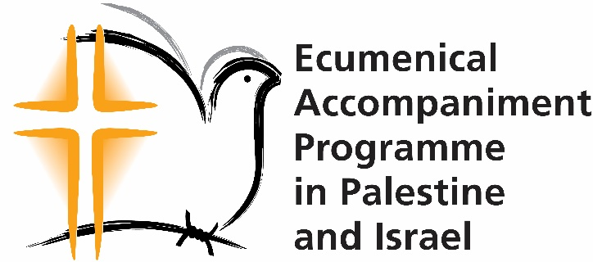
March 2024

Essential information for applicants

Dear applicant,

Thank you for your interest in applying to be an Ecumenical Accompanier. Ecumenical Accompaniers are human rights monitors. We call them EAs for short.

Before you apply, please read:
- This document which covers the role description and essential information for applicants.
- Further information about the programme and the role, we recommend you also read our other website pages www.quaker.org.uk/eappi and EAs' own eyewitness accounts on our blog: www.eyewitnessblogs.com.

Then fill out the application form by Sunday 14th April 2024, 5pm.

Please do apply as soon as you can. If we receive more than 60 applications, we reserve the right to close the application process ahead of the deadline above.

The interviews will take place 24-26 June; please keep one of those days free.

The next stages of recruitment are as described below.

If you have any queries, please email EAPPIrecruitment@quaker.org.uk. If you have difficulty filling in the form do contact us and we will do our best to help.

We look forward to receiving your application. Thank you for your interest in the programme.

The EAPPI UK & Ireland Team

Timeline for EA recruitment
Submit your application as soon as possible, and by the closing date of Sunday 14 April, 5pm

By Fri 31 May, we’ll let you know if we are inviting you to interview

If we invite you to interview, your three referees will need to send us their references by Sunday 9 June. You may wish to let them know this deadline ahead of time so that they are ready to fill in the reference form when requested to do so.

Interviews will be on Monday 24, Tuesday 25 and Wednesday 26 June. These will be held in London. We will pay travel expenses and provide accommodation for those living far enough away to need to say overnight.

You will need to attend interview on one of these days in order to progress your application so please keep these days free, and if there are any of them you already know you can’t make then please let us know on the application form.

Soon after your interview, we will let you know if we have appointed you.

We will also confirm which Group you will be in (on your application form you can give your preferences)

Timeline for EA service
Being an EA begins with doing a substantial amount of background reading, which we provide, before the ten-day training period.
For 2025 there will be two trainings.

Sunday 17 November – Thursday 28 November 2024, for EAs serving in:
- Group 97 departing late January 2025
- Group 98 departing early April 2025

Ten days in May or June 2025, TBC for EAs serving in:
- Group 99 departing mid-June 2025
- Group 100 departing late August 2025
- Group 101 departing early November 2025

EAs serve in Palestine

We hope to recruit a total of 20 EAs for 2025. Their service will include approximately three months in Israel and Palestine. We are aiming to send five groups, each consisting of several EAs. These are the approximate dates, which may vary slightly.

Group | Departs | Returns
97 | Late January 2025 | Late-April 2025
98 | Early April 2025 | Late June 2025
99 | Mid-June 2025 | Early September 2025
100 | Late August 2025 | Mid-November 2025
101 | Early November 2025 | Early February 2026

After EAs come back from Palestine, there is a two or three week rest period.

Then there is a four or five day Debrief and Advocacy week which allows them to debrief their time in Palestine and prepare for their advocacy.

EAs then go on to do a minimum of ten public speaking engagements and other advocacy. They fit these around their other commitments.

