## 

# Application Pack

## Public Affairs Officer

## Introduction

##### Grace Da Costa

##### Public Affairs and Media Manager



**This is an exciting time to join us and make a real impact.**

## Introduction

At Quakers in Britain we are working to bring Quaker values of peace and sustainability to the world, and support the Quaker community.

We have a clear strategy to:

* support Quaker meetings and other groups to be diverse, to thrive and grow,
* work for a sustainable and peaceful world,
* simplify structures and practices in our local and national organisation.

Our engagement with the UK government and parliament is an important and growing part of our organisation’s role. We are looking for a Public Affairs Officer to support this work. Your main focus will be our new project on truth and integrity in public life. We hope the information in this pack will fire your interest. Quakers are inspired by faith to work for a just, peaceful, and sustainable world. Our staff team shares those values and support this work as we seek to increase our impact.

If you would like an informal chat about the role before applying please email [graced@quaker.org.uk](mailto:graced@quaker.org.uk)

If you want to join our friendly, collaborative team we look forward to receiving your application.

You will find in this application pack background information about the Quakers, salary and benefits of working for us along with the job description and person specification for the post.

Best wishes,

**Grace Da Costa**

Public Affairs and Media Manager

### About Quakers

The Religious Society of Friends (Quakers) is a radical faith group with its roots in Christianity. It emerged in the mid-17th century as a group with no separate priesthood, and with a form of worship based in silence.

Quakers have been committed to peace, equality, simplicity and integrity throughout history, and are known for work to bring about social change over the years, such as on the abolition of the slave trade, the relief of suffering in wartime, improving living conditions for factory workers and the introduction of same-sex marriage.

You can read more about the story of Quakers at [www.quaker.org.uk/intro-quakers](http://www.quaker.org.uk/intro-quakers).

### About Britain Yearly Meeting

Britain Yearly Meeting (BYM) is the national umbrella organisation for Quaker meetings in Britain. We provide events and support services to nearly 500 local Quaker meetings across Britain, carry out peace, sustainability and social justice work on their behalf, and work to raise public awareness of Quakerism.

All Quakers in Britain are invited to come together at Yearly Meeting (the annual sessions of Britain Yearly Meeting), which meets to explore, through worship, the issues of concern to British Quakers, and to guide the work of the national charity.

We are a registered charity with an annual turnover of around £12m. Responsibility for the charity lies with the 15 Trustees of Britain Yearly Meeting, appointed from among the Quaker community. We are based at Friends House (opposite Euston station in central London), which houses our central offices accommodating 150 staff.

You can download our Trustees Annual Report and Financial Statements here: [www.quaker.org.uk/annualreport](http://www.quaker.org.uk/annualreport)

The work of Britain Yearly Meeting is carried out through six departments:

* Quaker Life supports Quaker meetings in their life and worship, runs Quaker outreach, provides training, and organises events for children and young people.
* Quaker Peace and Social Witness runs programmes on peace, peace education and climate justice, and supports Quakers to put their faith into action locally and nationally.
* The Communications and Fundraising department promotes public awareness of Quakerism, provides advocacy, media, web and publications services to the organisation, and oversees fundraising from Quakers, Quaker meetings and Trusts.
* Quaker Church Affairs looks after governance, events, and the shared identity and discernment of Quakers.
* The Finance and Property department oversees the budget and finances of BYM, including our ethical investment portfolio and properties.

Our wholly-owned trading subsidiary, Quiet Company, operates Friends House as a major conference venue and runs the building facilities. The company also runs Swarthmoor Hall, a historic house with accommodation in Ulverston, Cumbria ([www.swarthmoorhall.co.uk](http://www.swarthmoorhall.co.uk)).

You can read more about the governance structures of the Quaker organisation in Britain here [www.quaker.org.uk/structure](http://www.quaker.org.uk/structur#e).

## About us

### Our Values

## Our values

How we act as Quakers goes together with what we believe.

Quakers don’t have a fixed creed because we have found that the search for truth can lead us to new expressions of values as well as confirming existing ones. We call these values ‘testimonies’. Today we focus on equality, peace, truth, justice and simplicity, and how they relate to one another.

Our testimonies encourage us to work for a more just, peaceful and sustainable world. It’s not always easy to live this way, but as Quakers we encourage each other to keep trying.

#### Equality and justice

Quakers believe everyone is equal. This inspires us to try to change the systems that cause injustice and that stop us being genuine communities. It also means working with people who suffer injustice, such as prisoners of conscience and asylum seekers. We were campaigning for independent juries in the 17th-century, for marriage equality in the 21st, and for a range of things in between.

#### Peace

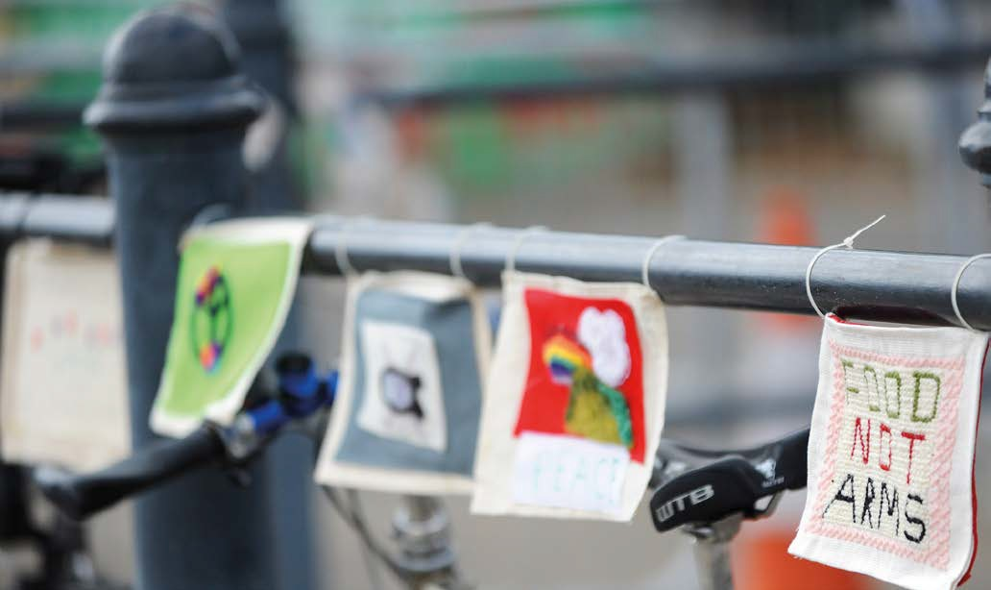Quakers are perhaps best known for our peace testimony. It comes from our belief that love is at the centre of existence and that all human life is of equal worth. It has led Quakers to refuse military service and work creatively for peace. This has ranged from practical work in areas affected by violent conflict to developing alternatives to violence at all levels. This could be personal or international.

#### Truth and integrity

Quakers try to live according to the deepest truth we know, and we connect most deeply to this in the stillness of worship. This means speaking the truth at all times, including to people in positions of power. As we are guided by integrity, so we expect to see it in public life.

#### Simplicity and sustainability

Quakers are concerned about excess and waste in our society. We want to make sure our use of natural resources is sustainable. We try to live simply and to find space for the things that really matter: the people around us, the natural world, and our experience of stillness.

The process of living out our faith is often called Quaker Witness – you can find out more about Quaker work by listening to our podcast: [www.quaker.org.uk/our-work/podcast](http://www.quaker.org.uk/our-work/podcast).

Britain Yearly Meeting is a national charity employing around 200 people. Its purpose is to work for, with and on behalf of Quakers in Britain.

## Working for Britain Yearly Meeting

### About our organisation

Quakers is the name often used for the Religious Society of Friends. Although we have our roots in Christianity, we also find meaning and value in the teachings and insights of other faiths and traditions.

In Britain there are about 20,000 Quakers. We have 500 local Quaker Meetings, grouped into 72 ‘area meeting’ charities. All these charities are affiliated to Britain Yearly Meeting (BYM).

Britain Yearly Meeting (BYM) is a charity, formally known as ‘Britain Yearly Meeting of the Religious Society of Friends’. The trustees are appointed by and accountable to British Quakers; and because this work is done for and on behalf of Quakers from the whole of Britain, the work we do is known as ‘centrally-managed work’.

### A Quaker workplace

We aim for our workplace to be consistent with Quaker values – broadly the same as most well-run progressive organisations. For example:

* We expect staff to respect each person regardless of age, race, religion, gender identity, sex, sexual orientation, disability, marital or civil partnership status.
* We avoid unjustifiable and unlawful discrimination in our employment practices
* We follow good employment practice, with clear and supportive line management
* We have a 1:4 ratio between the lowest and highest salaries
* We aim to be open and honest in all our work
* We avoid titles such as ‘Mrs’ or ‘Mr’
* Very few jobs with BYM are restricted to Quakers, although about 1/3 of the staff are Quakers or linked to Quakers in some way.

### The Quaker way of life

The Quaker way is based on silent worship, as a way to help people connect directly to God. Quakerism began in Britain in the 17th Century. Its roots are in radical Christianity, although today not all Quakers call themselves Christian.

Quakers share a way of life rather than a set of beliefs. We seek to experience God directly, within ourselves and in our relationships with others and the world around us.

Quakers are ordinary people, who try to live their values they can. This leads many Quakers to work for a better world.

Values that are important to us include truth and integrity, simplicity, equality, peace, and sustainability.

You do not need to be a Quaker to worship with us at one of our meetings.

#### You can find out more:

* From our website: [www.quaker.org.uk](http://www.quaker.org.uk).
* By reading Advice and queries which is an introduction to Quaker belief. Read it online at <http://qfp.quaker.org.uk>.
* By visiting the Quaker Centre at Friends House, which has leaflets and books, and volunteers who can answer questions.
* Or by requesting a free information pack from [www.quaker.org.uk/more-information](http://www.quaker.org.uk/more-information).

### Advocacy and Media team

## About the team

The Advocacy and Media team where this role sits is part of the Communications and Fundraising department. Other teams in the department work on the website, publications and content, and fundraising. The objectives of the department are:

* Bring Quaker values to the world
* Show how Quakers are active and relevant
* Increase the number of Quakers
* Engage Quakers in centrally-managed work
* Help Quaker meetings to thrive.

The Advocacy and Media team focuses on the first two of these objectives. It includes the functions of: public affairs in Westminster, Holyrood and the Senedd; interfaith and ecumenical relations; media; and social media. We work closely with campaigns colleagues in our Quaker Peace and Social Witness department, and much of our work is done in coalition with other organisations.

Our main UK public affairs priorities are climate justice and democracy. Within climate justice, we focus on ‘loss and damage’ – the impact the climate crisis is having on people around the world right now. We are raising awareness of this issue among UK politicians to try and increase the flow of money from rich countries, who did most to cause the climate crisis, to poorer countries, who did least to cause it but are suffering is effects first and worst.

Within democracy, we focus on improving truth and integrity in public life. Truth and integrity are core Quaker values, which we believe have been undermined in the UK political system in recent years. Our project will involve building relationships with people in government, parliament and civil society to try and work with them to improve the situation.

We have created the role of Public Affairs Officer to support this work in 2023-2024. In this role you will assist the Public Affairs and Media Manager to conduct research into stakeholders and issues, organise meetings with stakeholders, and keep colleagues and Quakers informed about the work and opportunities to get involved.

This is an exciting opportunity to build your knowledge and experience of UK public affairs work and be part of a project to improve the UK’s political system.

## Organisation chart

### Job purpose

## About this post

The role of the Public Affairs Officer is to provide support to the Public Affairs and Media Manager’s role in influencing attitudes, behaviour, policy and legislation in the UK government and parliament.

### 1. Key accountabilities and main tasks

* Assisting with stakeholder mapping – identifying stakeholders who are interested and influential in this area, both in civil society and in parliament
* Assisting with research into policy issues and helping to draft briefings on them.
* Monitoring developments in the media, parliament and civil society and keeping colleagues updated
* Maintaining logs of external and Quaker individuals and organisations who are interested and involved in the work.
* Helping to arrange, conduct and take notes at meetings with stakeholders. This could include:
  + Planning what needs to be done, by when
  + Finding suitable dates and times
  + Booking rooms and catering
  + Drafting and sending invitations
  + Logging RSVPs and responding to queries
  + Drafting briefings for organisers and participants
  + Assisting with conducting the meetings
  + Taking notes
* Helping to keep colleagues, Quakers and wider audiences informed about the work as and when appropriate
* Assisting with monitoring, reporting and evaluation of the work

### 2. Intellectual demands

* Positive and proactive attitude
* Ability to maintain confidentiality
* Good interpersonal and communication skills
* Strong time-management and organisational skills

### 3. Judgements

* Prioritising competing demands in consultation with line manager
* Informing colleagues about relevant developments
* Deciding what is appropriate to say or write depending on context and audience

### 4. Use of resources

* No budgetary responsibility, though the role-holder may be asked to contribute information for budget setting
* The post holder will be expected to use programme resources effectively, and in a way that aligns with BYM’s values and ethical commitments

### 5. Working conditions

* The post makes no unusual physical demands.
* Occasional travelling and working outside normal hours may be required.

### 6. Communications

Internal (60%)

* Liaising with line-manager and other colleagues involved in project
* Keeping colleagues updated on the project and external developments

External (40%)

* Sending communications to external stakeholders and responding to queries
* Assisting with external stakeholder meetings and events

### Other responsibilities

* To undertake duties and responsibilities commensurate with the post
* Responsible for ensuring that Quakers in Britain’s Safeguarding Policy is adhered to in all aspects of the role
* Responsible for ensuring that Quakers in Britain’s Equal Opportunities Policy is adhered to in all aspects of the role
* Responsible for ensuring that Quakers in Britain’s Health & Safety Policy is adhered to at all times
* Responsible for ensuring that Quakers in Britain’s commitment to sustainability is adhered to in all aspects of the role
* Responsible for ensuring that Quakers in Britain’s Staff handbook is adhered to at all times.

This is list of the attributes that a public affairs officer could have. We know that no-one will match up perfectly to the whole list. We are looking for the best mix of skills and experience that fits these needs.

## Person specification

### Essential qualifications

* Educated to degree level or equivalent experience

### Essential knowledge

* Knowledge of and sympathy with Quaker values
* Knowledge of how the UK government, parliament and civil society works

### Essential experience

* Communicating effectively with a range of audiences using different verbal and written formats
* Conducting or assisting with research and condensing complex information into concise and persuasive content
* Working in a team

### Essential skills

* Excellent interpersonal skills, with the ability to engage professionally with a variety of people
* Excellent written and verbal communication skills
* Good teamwork skills
* Time-management and organisational skills
* IT skills, confident in the basics of Outlook, Word, Excel and Powerpoint

### Desirables

* Knowledge of one or more current Quakers in Britain campaign issues
* Experience (paid or voluntary) of working in Westminster public affairs

Salary

## Salary & benefits

£30,916

Duration

Fixed term for two years.

Location

Based at our offices in London (NW1). You can work from home some of the time by agreement with your line manager.

This role is London-based because it will require you to come to the office and Westminster regularly and sometimes at short notice for meetings and events.

Hours of work

35 hours per week, Monday to Friday.

Flexible working options

We are open to discussions about flexible working patterns.

Holiday

27 days a year plus bank holidays and three days for Christmas closure.

Subsidised café

We have an on-site café which provides subsidised meals as well as a bookshop selling ethically sourced goods.

Cycle to work scheme

We offer a cycle to work scheme which helps you save money on a new work bike and spread the cost of the bike over monthly tax-free instalments.

Annual Season Ticket Loan

We will provide with a loan of up to £7,500 to cover the cost of your season ticket repayable in 11 monthly instalments.

Sabbatical scheme

Staff are able to take a nine-month unpaid sabbatical leave after five years’ continuous service.

Pension scheme

Quakers have a generous pension scheme where we contribute 8% of your salary and you contribute 3% of your salary. You have the option to increase your contributions should you wish and to pay your contributions via salary sacrifice.

Sick pay scheme

We have a very generous sick pay scheme:

If you have less than 12 months service, you are entitled to full sick pay for 3 weeks followed by three weeks at half pay.

After 1 years’ service, you are entitled to full sick pay for 3 months followed by 3 months at half pay, subject to a maximum of six months since the start of your service

After 4 years’ service you are entitled to full sick pay for six months followed by six months at half pay, subject to a maximum of 12 months.

Private Health Insurance

If you are off work due to sickness for more than 52 continuous weeks you will be eligible, subject to requirements of the scheme, to sick pay.

Employee Assistance

Quakers offers access to an independent, confidential employee assistance programme, available 24 hours a day.

Family Friendly Policies

Our family friendly policies give enhanced maternity and adoption leave. Once you have one year’s service by the 15th week before your baby is born or you adopt, you will be entitled to six weeks at full pay, 20 weeks at half pay and 13 weeks at SMP.

Apply online at [www.quaker.org.uk/jobs](http://www.quaker.org.uk/jobs).

The closing date for applications is:

**Midnight on 8 January 2023**.

The principles of equality and diversity are important to Quakers in Britain in all aspects of its work. We encourage you to fill in our diversity monitoring form when applying. The information you provide will helps us to monitor and refine our employment practice and respond to the needs of the diverse range of people that the organisation comes in to contact with.

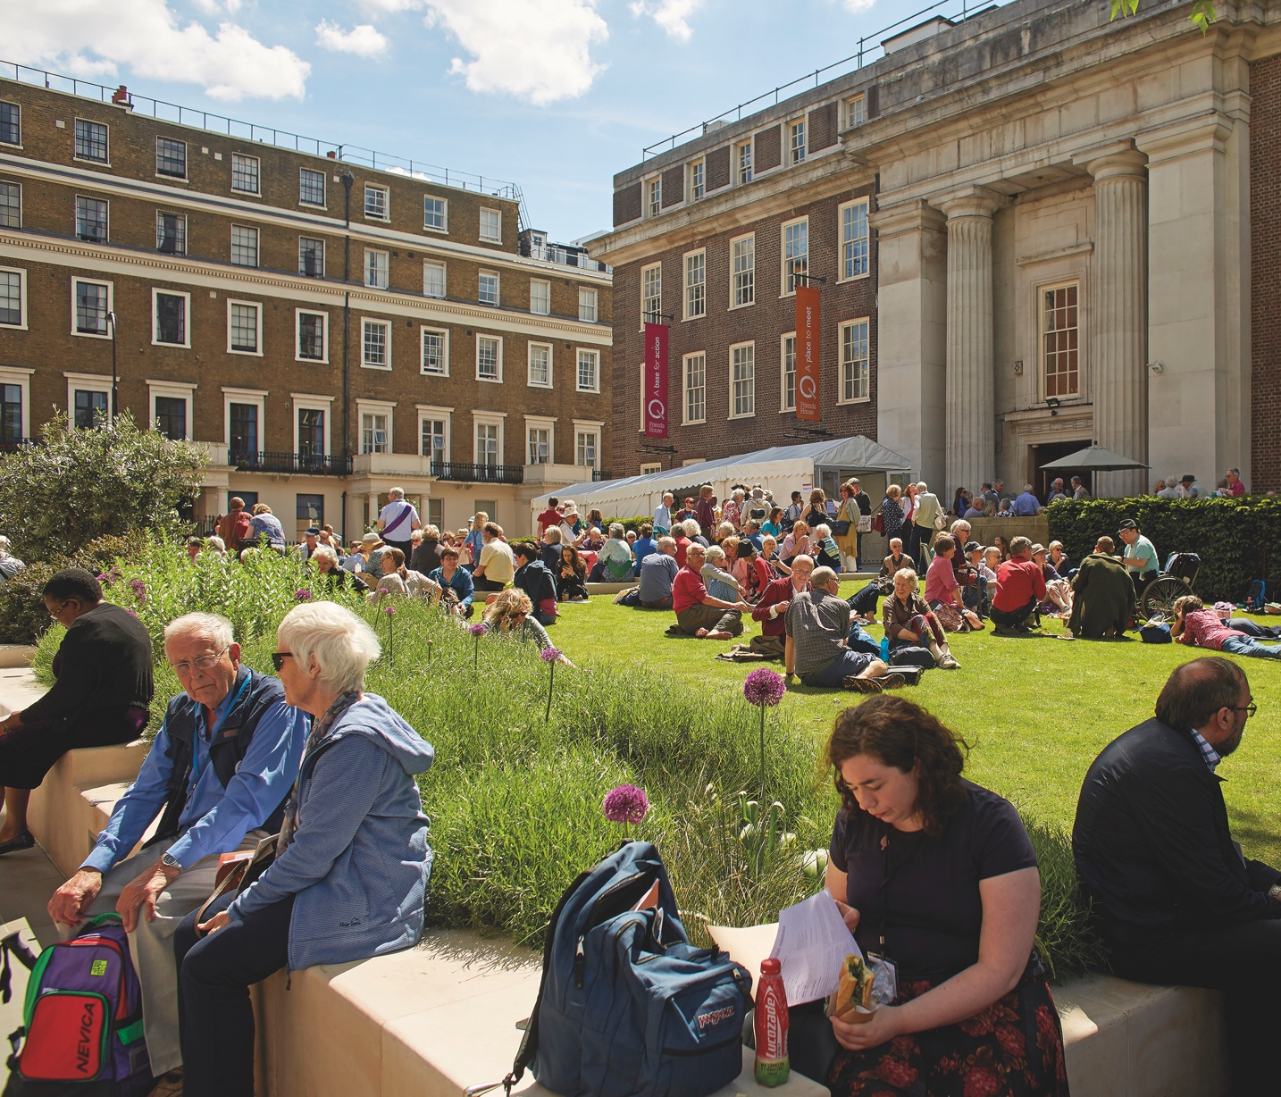We will consider your application immediately after the closing date and get in touch with you as soon as possible.

Interviews will be conducted by Grace Da Costa, Public Affairs and Media Manager; David Loxton, Head of Communications and Fundraising; and Dixe Wills, Campaigns Coordinator, on **17 January 2023**.

We do not send individual acknowledgement of applications due to the high volume of applications we receive and we only contact candidates who have been shortlisted for an interview. If you do not hear from us within two weeks of the closing date your application has not been successful on this occasion.

## How to apply