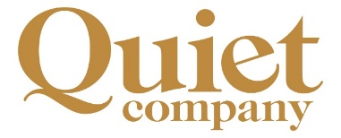

**Quiet Company seeks New Company Director**

Quiet Company, the sole trading subsidiary of Britain Yearly Meeting, is seeking a new Company director to join the board in the early summer of 2022 for up to three years. The Company operates a conference, events, and catering business at Friends House (London) and oversees the running of Swarthmoor Hall (Cumbria), the Friends House bookshop, and facilities on both sites on behalf of BYM, the charity.

The Company is currently facing the effects of the COVID-19 pandemic which has greatly affected its ability to trade, so it is looking for Friends with proven experience in strategic, commercial and business leadership and governance.

You should currently be in membership of the Society of Friends or in the process of joining; familiar with the Quaker business method; likely be in work and/or have relevant recent experience in running or being part of a company.

Key skills and experience being sought include:

* Hospitality or events management
* Retailing or running a small public attraction
* Human resources
* Strategic business and planning

You will be seeking experience of being a Company director; pre-pandemic, the company was approaching a substantial turnover of £5m. You will have an interest in developing sustainable and ethical business and supporting peace and social justice causes, including work to expand the work opportunities of ex‑offenders. There are opportunities to develop the Company further, but at the current time the board are looking at recovery from COVID-19 and developing new models and ways of working.

Time commitment: up to five half-day meetings per year (normally held in the afternoons and currently online), plus one full away day per year and one residential midweek meeting every two years at Swarthmoor Hall in Cumbria. The board is seeking to diversify its membership further and is taking steps to make its arrangements more inclusive, including meeting face-to-face only twice a year. We actively welcome interest from the BAME community and young Friends.

If you are interested in being part of a vibrant company and helping it flourish after the pandemic, please email Sherry-Ann Mitchell for more information: sherrym@quaker.org.uk.

Closing date 11th February 2022