Dear Applicant

**Local Development Workers (3 posts)**

* + - East Midlands (Derbyshire, Nottinghamshire, Lincolnshire, Leicestershire)
    - Gloucestershire, Bristol, West Wiltshire and North, Mid and East Somerset
    - Oxford & Swindon, Banbury & Evesham, Mid Thames and Chilterns

Thank you for your interest in the above posts. The job information pack contains the following:

* Job Description and Person Specification
* Guidance notes
* Equality & Diversity information
* Information about working for Quakers in Britain

If you would like more information about the posts, or have any questions, please contact Alistair Fuller on [alistairf@quaker.org.uk](mailto:sophies@quaker.org.uk). You can arrange a phone or video conversation if you wish.

If you would like to apply for this post, please click on the link on the website to complete the online application form. You must ensure that you address all the criteria set out in the person specification for the post. Make sure you give evidence which shows how you meet the criteria, not just telling us that you did it.

The personal information that you have supplied will only be used for recruitment and selection purposes. You should refer to the Privacy Notice on our website, which sets out how BYM will deal with the personal and sensitive data you have provided in your application form and supporting information.

We would be grateful if you could also complete the Equality and Diversity Monitoring Form. The principles of equality and diversity are important to Quakers in Britain in all aspects of its work. The information you provide will help us to monitor and refine our employment practice and respond to the needs of the diverse range of people that our organisation comes in to contact with. The personal data provided will be kept securely by HR and will not be shared with any member of the selection panel.

Please ensure that you complete your application by the closing date. We do not accept CVs as an application for posts, but you can attach your CV to the online application form if you wish.

**Closing date**: Monday 6th December 2021 (9am)

**Interviews:** Week of 10th January 2022 (they will take place by video call, and will include a prepared task and a panel interview).

**We do not send individual acknowledgement of applications due to the high volume of applications we receive, and we only contact candidates who have been shortlisted for an interview. If you do not hear from us within two weeks of the closing date, your application has not been successful on this occasion.**

Your application form and supporting details will be kept as legally required for six months in case of a dispute, and thereafter will be destroyed. Thank you for your interest in the post, we look forward to receiving your application.

**Job Description**

|  |
| --- |
| **JOB TITLE:** Local Development Worker    **REPORTING TO**: Team Leader    **RESPONSIBLE FOR**: No line management responsibility  **DEPARTMENT**: Quaker Life  **DATE**: December 2020 |

**Job purpose:**

Work with Quaker communities in a particular geographical area to enable them to thrive in a way that meets the aspirations of Our Faith in the Future.[1]

The support given will be flexible, responding to the needs and circumstances of Quaker communities in each area. This is likely to include a mixture of spiritual, practical, pastoral and facilitative approaches, as well as offering opportunities for community development and learning either provided directly by the worker or by others.

Workers will develop a work plan that will enable them to build honest, trusting relationships with Quaker meetings (and other Quaker groups) in order to build participation, inclusivity and leadership at a local level. This will be done with the support of a team leader, and will be designed round the aspirations and needs of the locality. The work will enable Quakers to further build and develop community, explore and act on leadings and use Quaker processes effectively and in ways that are spirit-led. The work will help strengthen connections across the area, between different parts of the Yearly Meeting and between local Quaker communities and the work of BYM and Woodbrooke.

Local development support is a critical component of BYM and Woodbrooke’s integrated support for meetings strategy. The experience of LDWs will help to shape and identify themes and priorities within this strategy, ensuring that it is ‘meeting centred’. They will also help to develop and on occasion contribute to wider support for meetings work including projects and events offered by BYM and Woodbrooke.

All aspects of the work will be embedded in Quaker testimony and practice; guided by the aspirations of Our Faith in the Future and underpinned by the strategic priorities of Britain Yearly Meeting and Woodbrooke.

1. **Key Accountabilities & Main Tasks**:
   1. **Develop understanding of and respond creatively to the needs and agendas of local Quaker communities:** (c35 % of worker’s time).[2]

**This includes:**

* Developing understanding of what is already happening within local Quaker communities, including key people, concerns and areas of activity.
* Building trusting relationships - including by spending time with and participation in Meeting for Worship with different meetings and groups
* Careful listening in order to understand how Quakerism is lived and experienced; explore the needs and aspirations of communities and identify both presenting and any underlying needs
* Facilitating groups to explore a potentially wide ranging set of questions, thoughts and leadings, and to identify actions that may flow from these. (For example in relation to community building, spiritual nurture, property, role-holding, developing concerns, conflict, witness etc.)
* Working with Quakers and colleagues to plan, deliver and follow up interventions
* Encouraging and enabling Quakers to understand and access the possibilities and benefits of local development support as well wider sources of support from BYM, Woodbrooke and other appropriate organisations. Where appropriate brokering the latter
  1. **Support local leadership development:** (c35% of worker’s time)

This includes:

* Helping role holders, meetings and others to use Quaker processes and discipline effectively, including working with and drawing on colleagues with specialist expertise as appropriate.
* Encouraging the development of individuals to use their gifts to serve Quaker communities through personal support, enabling access to learning, training and development, providing opportunities and encouragement.
* Working with and drawing on colleagues with specialist expertise, supporting meetings to uphold good practice and legal requirements – e.g. in governance, safeguarding, employment, charity law.
* Supporting the development of local and regional networks to foster community, share learning, experimentation and good practice
* Accompanying and supporting Friends to identify, develop and deliver projects – ensuring that these remain locally owned and implemented. (Not to deliver these.)
* Supporting meetings to become more welcoming, accessible and diverse including through experimentation with different expressions of Quaker community.
  1. **Contribute to YM-wide support for meetings strategy** (c20% of worker’s time)

This includes:

* Share learning and develop thinking with wider teams to continually develop BYM/Woodbrooke’s support for meetings work and its delivery in a way that reflects local needs and experience.
* Work with colleagues to develop and deliver Yearly Meeting wide support for meetings programmes or events as agreed with team leader.
* Promote wider BYM and Woodbrooke support for meetings work as appropriate to local needs and circumstances.
* Help BYM and Woodbrooke to communicate the work effectively by identifying and writing up stories, collecting information and helping to build a culture where Quaker communities are willing and able to share their stories with others.
* Where appropriate, sensitively challenge Quaker communities to develop and broaden thinking in line with Yearly Meeting priorities/leadings
* Use agreed monitoring and evaluation processes to record and report on the work to help BYM and Woodbrooke identify the difference the work is making
* On occasion – and as agreed with team leader - work in other geographical areas and/or with other BYM/Woodbrooke support for meetings staff (including, but not limited to, using the gifts within the staff team well, for developing new approaches, and to cover absences)
  1. **Professional and team development** (c10% of worker’s time)

This includes:

* Share and develop learning and expertise with colleagues - particularly any new or specialist areas of focus.
* Remote and in person participation in regular team and organisational meetings across BYM and Woodbrooke.
* Active participation in supervision meetings and annual reviews/planning with line manager.

1. **Intellectual Demands**

* Excellent interpersonal and communication skills
* Critical thinking and problem solving.
* Gathering and analysing information.
* Planning and organisation.
* Verbal and written communication.

1. **Judgements**

* Work within the framework of BYM and Woodbrooke’s integrated support for meetings strategy under the direction and line-management of a team leader
* Negotiate conflicting/competing points of view within and between meetings.
* Identify and respond appropriately to the presenting and underlying needs of Quaker communities.
* Decide upon the most suitable types of support to offer from the available resources, bearing in mind competing needs and outcomes.
* Manage own workload and priorities, with the support of team leader.

1. **Use of Resources**

* There are no staff or budget management responsibilities, but the work includes working alongside and supporting volunteers.
* Responsibility for managing resources allocated by budget holders, in line with organisational requirements and guidance e.g. for travel expenses, procurement and sustainability.
* Responsibility for safekeeping of I.T. equipment and a mobile phone.

**5. Communications**

**Internal**: (paid staff)30%:

**External**: (including local and area meetings, committees etc.)70%

**6. Physical Demands & Co-ordination**

The work may be either home and/or office based (to be agreed) and based in external locations. There is the requirement to travel regularly and to transport and lift I.T. equipment and prepare resources.

**7. Working Conditions and Emotional Demands**

**7.1 Hours**

The post holder will work an average of 28 hours per week. The work requires a good degree of flexibility from the worker to be available on a variety of weekends, weekdays and evenings.

* The main days and hours to be worked in any calendar month will be agreed in advance with the team leader. A record should be kept of hours worked for regular joint review.
* Local development workers should expect to work up to an average of 5 weekend days a month, most often on a Sunday.
* There is occasional evening work. This is usually for phone calls with Friends, and can therefore be done at home. Occasionally, there may be evening meetings (see travel below).
* It may be necessary to work some long days. Some overnight stays may be required.
* The post holder is required to work on a Wednesday as a core desk/office day. This enables team and organisational meetings and other activities to be held.
* Other desk/office days to support cross organisation collaboration would normally be on weekdays and during regular working hours. (BYM core office hours are between 10am and 4pm)
* BYM operates a time off-in lieu (TOIL) system for agreed work that may be required over and above contracted hours. The BYM flexible working policy and TOIL guidance provide more information about how this works.

**7.2 Base**

The base for the role will be agreed in discussion with BYM, and will suit the needs of a particular locality. BYM will pay reasonable costs for the office space as appropriate. It could be:

* In an office space in a Quaker Meeting House
* In a shared office or hot desk facility
* At home (for which a home working allowance will be paid)

In many cases the worker will be based in a different geographical area from their direct colleagues.

BYM will provide suitable furniture, IT and other equipment to equip an office as needed.

**7.3. Travel**

The post-holder will be required to travel widely their regions. This is likely to include some overnight stays.

In addition to this it will be necessary to work, attend meetings or participate in trainings at locations outside of their region – primarily (but not limited to) Friends House (London), Woodbrooke (Birmingham) and QiB Yorkshire Centre (Leeds). This is likely to include in the region of 10 trips per year and may include overnight stays. The pattern of these will be agreed in consultation with line managers.

Britain Yearly Meeting prioritises the use of public transport as part of its commitment to sustainability. Where this is not practicable, the post-holder may use their own car, or hire a car, in line with BYM policy and procedures.

It should be noted that some locations are extremely difficult to access by public transport, especially on a Sunday.

Reasonable travel costs from the office base will be paid in line with BYM policies and procedures.

The post holder requires emotional resilience and the ability to remain grounded. There may be conflicting opinions or complex situations to manage as Quakers share and explore their spiritual journeys.

**OTHER RESPONSIBILITIES:**

* To undertake duties and responsibilities commensurate with the post
* Responsible for ensuring that BYM’s Safeguarding Policy is adhered to in all aspects of the role
* Responsible for ensuring that BYM’s Equal Opportunities Policy is adhered to in all aspects of the role
* Responsible for ensuring that BYM’s Health & Safety Policy is adhered to at all times
* Responsible for ensuring  that BYM’s commitment to sustainability is adhered to in all aspects of the role
* Responsible for ensuring that Britain Yearly Meeting’s Staff handbook is adhered to at all times.

**Person Specification**

**ESSENTIAL KNOWLEDGE**

* Knowledge of and sympathy with Quaker worship, practices, structures and values.
* Knowledge of community development and empowerment.
* Awareness and understanding of the particular issues/cultural context of the region.

**ESSENTIAL QUALIFICATIONS**

* There are no specific qualifications that are essential to this role.

**ESSENTIAL EXPERIENCE**

* Using a variety of group work and facilitation methods to help groups explore challenges, test new/competing ideas, identify actions and come up with solutions.
* Supporting communities, groups and/or networks to foster community, share learning and develop and deliver new initiatives.
* Supporting and developing individuals to understand their situation, use their gifts and facilitate change
* Identifying conflict at an early stage and supporting others to work through and address this

**ESSENTIAL SKILLS AND ABILITIES**

* A good listener who is open to new ideas.
* Ability to overcome barriers and identify creative solutions.
* Ability to work diplomatically with a diverse range of people and groups – being approachable and supportive but also challenging when required.
* A commitment to inclusivity with the ability to embed this in group and other working practices.
* Ability to work proactively under own initiative and collaboratively as part of a team.
* Ability to plan, organise and deliver work according to guidance and agreed standards.
* Ability to gather and record information effectively.
* Excellent verbal and written communication skills, including presentation skills.
* Confident IT user (including with Word, Excel, Outlook, databases, use of technology to work with colleagues in other locations) with the ability to learn new software and applications quickly.

**DESIRABLES**

* Training, qualifications or substantial experience in one or more of the following: formal or informal education, community development, volunteer management, youth and/or community work, faith organisations, group work, facilitation and/or training others.
* Experience of working with a wide (e.g. national) but dispersed network of community or faith groups.
* Experience of using Quaker processes and approaches – e.g. threshing meetings, meetings for clearness
* Driving licence

**Guidance Notes**

**PLEASE READ THESE NOTES BEFORE COMPLETING THE APPLICATION FORM**

These notes have been designed to assist you by providing information about BYM’s recruitment process.

**Preparation**

You should spend some time reviewing your skills, achievements and experience, identifying those that are relevant to the job.

**Making your Application - Job Details**

You should read the job description, person specification, advert and any background information so you know what the job involves. Think about why you are interested working for the Religious Society of Friends (Quakers in Britain), the post and how your knowledge, skills and experience (paid or non-paid) would enable you to be effective in the role.

**Supporting Statement**

You should write a supporting statement setting out the reasons why you think you are suitable for the post. **You must address each item on the person specification.** You should highlight the experience, skills, achievements that you would bring to the post including, those that you have gained through previous employment, voluntary work or any other relevant experience.

**Accuracy of Information**

The information that you provide to the Religious Society of Friends, both on your application form and at interview must be accurate. If we discover that any information provided is inaccurate, an offer of employment may be withdrawn. Where an appointment has been made, we may take disciplinary action up to and including dismissal.

**Data Protection**

You should be aware that information contained in or derived from your application may be retained in both manual and computerised form for the purpose of recruitment administration, the production of depersonalised statistical data relevant to recruitment or equality issues and on appointment, personnel, payroll and pensions administration.

If your application is unsuccessful your application form will be retained for a maximum period of six-months. We will not share your information with any other organisation unless required to do so by law.

**Equality & Diversity**

**QUAKER FAITH & PRACTICE 23.36**

*'At the Centre of Friends’ religious experience is the repeatedly and consistently expressed belief in the fundamental equality of all members of the human race. Our common humanity transcends our differences...We aspire not to say or to do anything or condone any statements or actions which imply lack of respect for the humanity of any person.' (Meeting for Sufferings, 1988)*

The Religious Society of Friends (Quakers) is committed to equality. In order to monitor our commitment to equality we ask applicants for posts to complete our equality monitoring form. The information provided is treated in the strictest confidence and is detached prior to shortlisting. The forms are retained by HR and the panel do not have sight of them.

**Appointment Process**

After the closing date has passed, the recruiting manager and the interview panel will shortlist applicants who have demonstrated that they meet the essential criteria set out in the person specification. Only candidates shortlisted are invited for interview. **If you do not hear from us within two weeks of the closing date, your application has been unsuccessful.**

Normally applications received after the closing date are not considered

**Interview**

If you are shortlisted for interview, you will be invited to a selection process. A panel of two or more, including the recruiting manager conducts all interviews. If there are any special arrangements associated with the selection process e.g. tests or presentations, you will be informed accordingly.

**Disability**

If you are an applicant with a disability and have any specific needs, adjustments that you would like us to make or queries please contact HR at [quakeremploy@quaker.org.uk](mailto:quakeremploy@quaker.org.uk)

**Interview Outcome**

If you are invited to attend an interview/and or selection process you will be informed either verbally or in writing of the outcome. The successful candidate will have the decision confirmed in writing as an offer of employment. Unsuccessful candidates will be offered the opportunity for feedback.

**References**

When completing your application, you are asked to provide us with the details of three referees, one of which must be from your most recent employer. If you are a student, one of your referees should be from a tutor. We only contact referees with your permission after an offer of employment has been made.

All offers of employment are conditional upon the receipt of references that are satisfactory to BYM, verification of right to work in the UK, medical health clearance, and where applicable, verification of qualifications and Disclosure and Barring Service.

**Right to Work in the UK**

Under Immigration Act 2014, employers must ensure that any prospective employee is legally entitled to live and work in the UK. If you are offered employment by the Religious Society of Friends (Quakers) you will be required to produce an official document confirming that you are entitled to live and work in the UK, e.g. passport; full birth certificate and official document confirming your name and national insurance number; or a passport/travel document/letter from the Home Office.

**Queries**

If you require further information or wish to raise any matters with regard the appointment process, please contact HR [quakeremploy@quaker.org.uk](mailto:quakeremploy@quaker.org.uk)

**Complaints**

Applicants for posts within the Religious Society of Friends (Quakers) have the right to complain if they feel they have been unfairly treated or discriminated against during the recruitment process. If you feel that this is the case you should contact HR at [quakeremploy@quaker.org.uk](mailto:quakeremploy@quaker.org.uk)

**Working for Quakers in Britain**

**About Quakers**

The Religious Society of Friends (Quakers) is a radical faith group with its roots in Christianity. It emerged in the mid- 17th century as a group with no separate priesthood, and with a form of worship based in silence. Quakers have been committed to peace, equality, simplicity and integrity throughout history and are known for work to bring about social change over the years, such as on the abolition of the slave trade, the relief of suffering in wartime, improving living conditions for factory workers and the introduction of same-sex marriage. You can read more about the story of Quakers at [www.quaker.org.uk/intro-quakers](http://www.quaker.org.uk/intro-quakers).

**About Britain Yearly Meeting**

Britain Yearly Meeting (BYM) is the national umbrella organisation for Quaker meetings in Britain. We provide events and support services to nearly 500 local Quaker meetings across Britain, carry out peace, sustainability & social justice work on their behalf, and work to raise public awareness of Quakerism.

All Quakers in Britain are invited to come together at Yearly Meeting (the annual sessions of Britain Yearly Meeting), which meets to explore, through worship, the issues of concern to British Quakers, and to guide the work of the national charity.

We are a registered charity with an annual turnover of around £12m, and assets of over £77m. Responsibility for the charity lies with the fifteen Trustees of Britain Yearly Meeting, appointed from among the Quaker community.

BYM has around 150 staff, many based at Friends House in Euston, with an increasing number working nearer their homes across the country. We are expanding our team of local development workers who work with groups of Quaker communities across Britain.

You can download our Trustees Annual Report & Financial Statements here: [www.quaker.org.uk/annualreport](http://www.quaker.org.uk/annualreport).

The work of Britain Yearly Meeting is carried out through five departments:

1. Quaker Life supports Quaker meetings in their life and worship, oversees Quaker outreach, provides training, organises events for children & young people and runs the Library of the Society of Friends.
2. Quaker Peace & Social Witness works on behalf of Quakers in the areas of peace, economic justice, sustainability and criminal justice, through campaigning, training, placements, community empowerment and by supporting Quakers in local meetings with their activities and concerns.
3. Quaker Communication & Services works to promote public awareness of Quakerism, provides advocacy, media, web and publications services to the organisation, and oversees fundraising from Quakers, Quaker meetings and trusts. It also provides a secretariat for the Quaker governance structures.
4. Quaker Finance & Property oversees the budget and finances of BYM, including our ethical investment portfolio, various properties and legacies.
5. Our wholly-owned trading subsidiary, The Quiet Company, operates Friends House as a major conference venue and runs the building facilities. This includes our main 1000-seat auditorium, The Light (see [www.friendshouse.org.uk](http://www.friendshouse.org.uk) and [www.thelightateuston.org.uk](http://www.thelightateuston.org.uk) for more information). The Quiet Company also runs Swarthmoor Hall, a historic house with accommodation in Ulverston, Cumbria (www.swarthmoorhall.co.uk).
6. 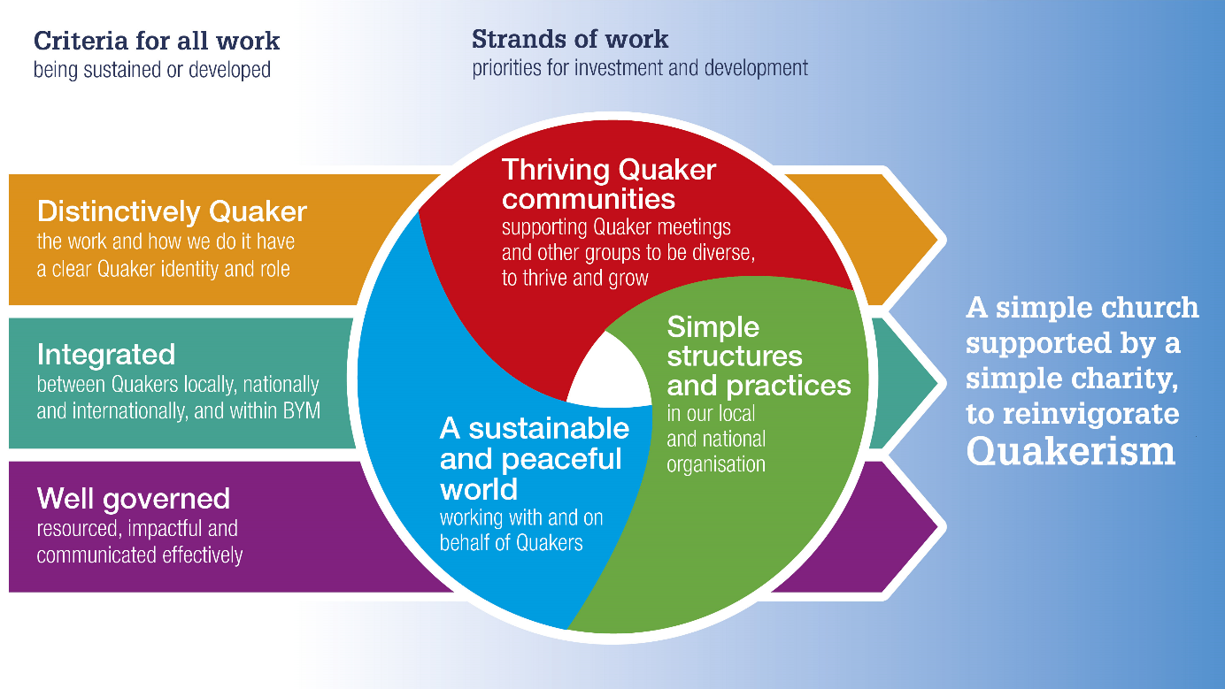You can read more about the governance structures of the Quaker organisation in Britain here [www.quaker.org.uk/documents/quakers-in-britain---a-short-guide-to-our-structures](http://www.quaker.org.uk/documents/quakers-in-britain---a-short-guide-to-our-structures).

## About Local Development Work

Local Development work is part of a move in Quakers in Britain to bring support closer to meetings and other Quaker communities. It is a partnership with Woodbrooke, the Quaker learning and research organisation. Quakers in Britain are committed to placing local development workers within reach of every Quaker community in Britain by summer 2022. The Supporting Quaker Communities Team (Quaker Life) is the main way in which the joint BYM/Woodbrooke integrated strategy for supporting Quaker communities is delivered.

Six local development workers are currently in post, three of whom have been there since 2016, as part of the Vibrancy in Meetings Pilot Programme. The Kent, Sussex and Surrey post is taking forward 5 years work by the previous post holder. The Cumberland and North East post has had some preparatory local development work done for about a year by a colleague. We will be recruiting six more workers by summer 2022. There is more information about the Vibrancy Programme, Local Development Work, and supporting Quaker communities, on the [Britain Yearly Meeting website](https://www.quaker.org.uk/our-organisation/support-for-meetings/meeting-centred-support).

We are holding two short (1 hour) online sessions for potential candidates who may want to know more about the work and to talk to some of the existing Local development workers. These will take place on the evenings of 24 and 29 November, both at 7.00 pm. If you would like to join one of these sessions, please email [alistairf@quaker.org.uk](mailto:alistairf@quaker.org.uk) to register.

Please indicate on your application form which post you are applying for. (You may apply for more than one).

## Our Values

How we act as Quakers goes together with what we believe.

We don’t have a fixed creed because we have found that the search for truth can lead us to new expressions of values as well as confirming existing ones. We call these values ‘testimonies’. Today we focus on equality, peace, truth, justice and simplicity, and how they relate to one another.

Our testimonies encourage us to work for a more just, peaceful and sustainable world. It is not always easy to live this way, but as Quakers, we try to encourage each other to keep trying.

### Equality and justice

Quakers believe everyone is equal. This inspires us to try to change the systems that cause injustice and that stop us being genuine communities. It also means working with people who suffer injustice, such as prisoners of conscience and asylum seekers. We were campaigning for independent juries in the 17th-century, for marriage equality in the 21st, and for a range of things in between.

### Peace

Quakers are perhaps best known for our peace testimony. It comes from our belief that love is at the centre of existence and that all human life is of equal worth. It has led Quakers to refuse military service and work creatively for peace. This has ranged from practical work in areas affected by violent conflict to developing alternatives to violence at all levels. This could be personal or international.

### Truth and integrity

Quakers try to live according to the deepest truth we know, and we connect most deeply to this in the stillness of worship. This means speaking the truth at all times, including to people in positions of power. As we are guided by integrity, so we expect to see it in public life.

### Simplicity and sustainability

Quakers are concerned about excess and waste in our society. We want to make sure our use of natural resources is sustainable. We try to live simply and to find space for the things that really matter: the people around us, the natural world, and our experience of stillness. The process of living out our faith is often called Quaker Witness – you can [find out more about Quaker work by listening to our podcast](https://www.quaker.org.uk/our-work/podcast).

**Quakers in the East Midlands**

**East Midlands**

The East Midlands patch contains three Area Meetings, Notts and Derby, Lincolnshire and Leicester. There is already good contact and co-operation between the AMs, though each have their own distinctive character.

**Notts and Derby**

At the end of 2020 there were 456 Quakers in Nottinghamshire with 9 local meetings, and 6 meeting houses. Meetings range in size from 9 to 167 (tabular statement, 2020).

As with many area and local meetings, our recent history falls into two or more parts: pre-covid, covid, and now that we are returning to some sort of normalcy.

Some ongoing initiatives include the Area meeting bi-monthly bulletin, developing family friendly and ‘simpler meetings’, training Mental Health First Aiders across the area meeting, a network of local safeguarding friends, re-invigorating the AM website. Thanks to the initiative of our area meeting minuting clerk, an archiving group was formed to rebuild the AM archive.

Pre covid the area meeting held 6 meetings for worship for business on a bi-motnthly timetable, visiting each meeting house in turn. Meeting was regularly preceded by a workshop organised by local Friends; there was a regular Quaker walk in Derbyshire after one, another provided a meal after the business meeting and an opportunity to socialise, two hosted Elder and Pastoral Care meetings in the morning and one LM invited Friends to share a session of favourite quotes from from QF&P as well as their regular Meeting for Worship (this last being on a Sunday). Several LMs also organised visiting theatre companies and these were well patronised by Friends from across the area. An annual weekend residential retreat was held in Derbyshire, with a varied and interesting program organised by local meetings in turn.

Since covid, activity has continued mostly on-line. Area meetings for businesses have moved on-line, an AM meeting for worship was instituted, local meetings have also held their meetings by zoom and remotely and ‘in the spirit’. LMs formed ‘telephone trees’ and similar to try and ensure on-going contact with Friends who could not engage with on-line worship. Several meetings developed or maintained newsletters; one meeting exchanged ministry by email. One local meeting organised a ‘non-residential’ residential day (in person and on line). Reopening meeting houses has been necessarily a slow process. From the beginning the board of trustees took an immediate lead in guiding local meetings and Friends through the ever changing maze of lock down restrictions, ensuring that they keep safe, and remain within the law.

Some of the challenges already nascent before the pandmic have become more acute, especially regarding recruiting post holders. We enter 2022 with our AM co-clerks retiring after completing their periods of service, and no replacements appointed; more trustees are also very much needed. Several Friends have been compelled to seek release from their roles.

**Leicester**

Leicester Area Meeting consists of 4 local meetings. Leicester, Oakham and Rugby have their own meeting houses, while Loughborough Local Meeting meets in a community centre. Leicester FMH is much larger than the other two meeting houses with several meeting rooms, a warden’s flat and a substantial garden and therefore has become in many ways the hub of Leicester Area Meeting. When the AM became a CIO and registered with the Charity Commission last year the Leicester Meeting House was listed as its registered office. Another reason for Leicester becoming the hub is that the distance across the AM from Rugby to Oakham is considerable and public transport links are poor.

Nevertheless all four meetings are busy and thriving, though sometimes they think they are not. Active members and attenders amount to about 150. Local and area business meetings are well attended, better than many other AMs as far as I can see, and understanding of right ordering is high. Involvement at national level is good.

**Challenges**: there is an absence of children and young people in some meetings, though Rugby and Leicester do have some and cater well for them; noms committees not always finding it easy to find people to fill important roles with more responsibility falling on the small number of committed Friends. Though the AM is financially well off we have yet to see the full impact of the pandemic on our income from lettings.

**Strengths**: work on social concerns is strong: prison chaplaincy work in Leicester and Rugby; asylum seekers in Leicester; sustainability and interfaith work in Loughborough; sustainability in Rugby. Tensions and disagreements are very rare and there are good relationships between the local meetings, local and area meetings and area meeting and trustees. Prior to the pandemic attendance at Sunday MfW was good and many mid week Meetings for Worship took place. Friends were keen to go to Woodbrooke and Yearly Meeting. We are nowhere near returning to “normal” yet and there is a worry that we are ceasing to know each other because of the difficulties of social

**Lincolnshire**

Around 150 Friends in Membership worship in our Area which is a widepread rural one comprising 8 Local Meetings.   Newark Meeting is geographically in Nottinghamshire but was the result of an outreach project by Brant Broughton Friends started in 2012.  Several of our Meetings are very small.  Getting together involves travelling long distance - Gainsborough, in the north and Spalding in the South.

We are anticipating during the next 2-3 years to hold a review of the spiritual life of our Meeting and concurrently a review of the property held by the area.  We are trying to simlplify our ways of working and sometimes find it difficult to fill roles.   We are trialling a programme of 6 business meetings a year - three of which are Fellowship meetings.

Meetings have been impacted by the pandemic and there have been a variety of ways in which Friends have continued to meet.  Some are happy using technology to provide blended meetings, while others are reluctant to engage with it.  We are actively seeking to improve the technology in order to be as inclusive as possible.  
Lincolnshire is the home to the International Bomber Command Memorial Museum and some Friends have been involved in developing the peace and reconciliation aspect of this museum.  Newark has the National Civil War Centre and a local Friend who works there is developing links with the Quaker Tapestry Museum and Swarthmore Hall.

**Quakers in Oxfordshire, Berkshire and Chilterns**

**Oxfordshire and Swindon Area Meeting**

OSAM is made up of Oxford LM, which is our largest LM with over 200 members, Swindon LM, with over 30 members and six smaller LMs with around 20 to 30 members each. The smaller LMs are, Abingdon, Burford, Charlbury, Headington and Marlborough. The distance between some LMs can be 50 miles apart with poor public transport.

Recently the Area Meeting has been looking at ways to strengthen connections between Local Meetings. In May 2021 our Trustees carried out a survey via a questionnaire and Zoom meeting to assess the health, wellbeing, perspectives, problems, successes and concerns of each Local Meeting during the pandemic and their vision for the future.

Results of the survey was presented at the September AM in a 2 hour lively discussion. A brief conclusion- there were different challenges and strengths among the LMs, and there was much energy expressed to share resources, learning and spiritual nurturing events between all LMs. Some proposals to strengthen the horizontal connections were made and the results were reported in the November AM. Since then, there has been:

* Sharing of reflections on the Swarthmore Lecture via Zoom in ‘Friday with Friends’ – Friends across four LMs participated.
* A retreat Day in Oxford
* Proposal for Spiritual Nurturing twice a month via Zoom
* Day gathering at Charney Manor with ‘Woodbrooke on the Road’ between three LMs.
* News of a Local Development Worker to be rolled out in our area in 2022

The first two initiatives were much appreciated and Friends look forward to the other initiatives rolling out.

**Banbury and Evesham Area Meeting**

Banbury and Evesham Area Meeting has 85 members and 100 attenders. The bulk of the membership is elderly, and it has been hard to fill roles in Area and Local Meetings.

The Area is responsible for C17th and C18th meeting houses; only one meeting house is a C20th building. While the older buildings are cherished, their care is demanding. The Area is spread across four local authority areas, making Area-wide activities difficult to organise.

Banbury Meeting House is located in the middle of the town and is in need of major investment. Its future is currently the subject of an Area-wide process of discernment. The Meeting is involved in the local Churches Together forum. Adderbury Meeting House to the south, is leased to the parish council and used by Quakers four times a year. Banbury Friends take the lead in organising the annual Adderbury Gathering there - a lecture by a national figure.

Before the pandemic, about 10 Friends attended Broad Campden Local Meeting. It met by Zoom through the pandemic, and resumed meeting in person in August with reduced numbers. It occasionally holds discussion meetings. A long-standing Light group meets fortnightly.

Friends at Ettington Local Meeting engage in local village activities for outreach, including the regular village breakfast and the annual Parish Meeting. They also invite children from the local school to visit our beautiful garden.

Evesham Meeting House has a Peace Garden open to the public. Meetings are blended and it is hoped to resume shared lunches and other activities. It is involved with Evesham Churches Together, and engaged with the local refugee group and food bank. It is hoped to put on musical events to promote outreach.

Meeting for Worship at Sibford Meeting House regularly concludes with “Afterwords”. It supports a range of charities.

Stratford-upon-Avon Local Meeting is active in Stratford Churches Together, with a particular focus on sustainability initiatives and a local project supporting the homeless.

An Area Day is held in July to provide a range of activities as well as the opportunity to bring people together socially from across the Area.

**Chilterns Area Meeting**

Chilterns is a small Area Meeting, with just seven Local Meetings and only 30 miles between the two most distant. Six LMs have their own Meeting House. Four are now regularly holding blended meetings.

The most obvious characteristic of our Area Meeting is the number of historic MHs we look after, and our connections with early Friends such as Penn, Elwood, Pennington. Jordans Meeting, in particular, gets many international visitors as a result.

We have a high proportion of elderly Friends, with very small numbers of children and young people, and consequently have trouble attracting young families to worship with us. Two of our Meetings are now critically small, such that the loss of one or two key Friends could result in the Meeting having to be laid down. We hope these are issues that a Local Development Worker might be able to help us with.

In terms of recent activity, obviously things have been limited this past two years, because of Covid.

Two of the most significant ongoing activities that have not been prevented by Covid are:

* our support for Wycombe Refugee Partnership. A few years ago, we used some legacy money to buy a house which is used by families who have newly acquired refugee status
* the use of Slough & Windsor MH six days a week as a day centre by Slough Homeless Our Concern

In 2019, we organised a three-day series of talks, discussion and workshops on the topic of *Why Conflict? Why Violence?* examining the roots of violence in our society.

This month, we hosted a production of the Journeymen Theatre's play, *Backdoor Parole*, at Amersham MH, which was also livestreamed. We have close connections with two prisons in the area, with Friends acting as chaplains, and one of our members being an ex-governor at Grendon.

Many Friends are also active in environmental concerns. We are also regularly represented in the protests against the London Arms Fair.

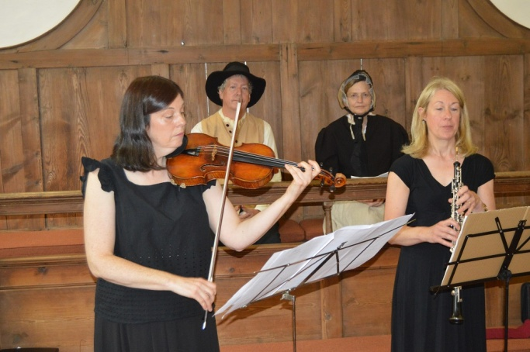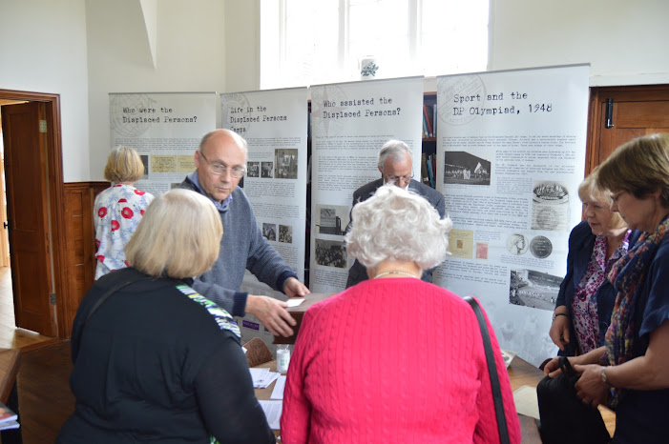

**Mid Thames** **Area Meeting**

Mid Thames Area Meeting has 6 local meetings and one new fledgling LM that is trying to stand on its own. The meetings are in Reading, Maidenhead, Newbury, Wokingham, Wallingford, East Garston and Didcot. Out of the local meetings, Reading Meeting is larger than all the others put together. Reading is urban and has a major university and Quaker School, Leighton Park. The other meetings are situated in beautiful Berkshire market towns and East Garston in a tiny village.

The difference in size and place makes for a lack of understanding of each other’s needs and awareness of joint responsibility.

We have three old listed meeting houses; two that are in houses given to the meetings at various times; East Garston used to be in a Nissan hut left by the Americans after the war and is now a beautiful little custom built meeting house; and Didcot that rents accommodation.

Reading Meeting is the only meeting with a regular children’s meeting but now that is only once a month and usually attracts all the children from the Area Meeting to make it a viable group. Traditionally Mid Thames Area Meeting was full of keen protesters to the AWE and at Greenham Common. We have our activists now but the protests are more disparate. Mid Thames has residential gatherings at Charney Manor in Oxfordshire. We have an all-day area meeting with a speaker for 4 out of 7 area meetings for business. For the last 2 years these have been on Zoom.

During Covid we all met virtually. We often had more people than usual attending with many people we had not seen for a while enjoying being able to attend so easily. Now we are back to physical meetings blended with a Zoom meeting but numbers are dwindling rapidly both on Zoom and physically. We look forward to the appointment of a Local Development Worker to support us to motivate ourselves and to rebuild a sense of cohesion.

**Quakers in the West of England**

**Gloucestershire Area Meeting**

Gloucestershire Area Meeting covers the whole of the modern administrative county of Gloucestershire. In the last tabular statement, we recorded 234 members and about half that number of regular attenders. There are eight local meetings, of which the largest are in Nailsworth and Cheltenham. Five of our meetings have their own Meeting Houses (four of them are listed buildings), while the other three meet in rented premises. Compared with some other Area Meetings, Gloucestershire AM is not financially well-endowed, and Trustees face a constant problem of how to maintain meeting houses and fund Quaker work within a limited budget.

Area Meeting meets eight times a year. From the beginning of 2022, responsibility for hosting and clerking each AM will rotate among the eight local meetings in turn, with a link clerk and assistant link clerk to maintain continuity. Meetings now take place on Saturday afternoons, to enable Friends who can to travel on public transport.

During the pandemic, both AM and local meetings have met online. They are gradually returning to face-to-face meetings. Some meetings lost attenders during lockdown, while others found renewed interest among some who had not been to meeting for a long time. Some of our meetings face problems of declining membership; they are not moribund but are working hard to reinvent themselves.

Among the most important concerns which Friends have brought to Area Meeting over the last few years are criminal justice (we have two Quaker prison chaplains); domestic violence; sustainability; Black Lives Matter and opposition to the arms fair at the Malvern showground. The AM and several local meetings are Sanctuary Meetings and involved with work with refugeees. The AM has recently decided that it needs to look for ways of strengthening its work with children, young people and families. Two Faith in Action Day co-ordinators help to organise events, meetings for learning etc for the AM as a whole.

**Bristol Area Meeting**

Bristol Area Meeting has a membership of 269 and 205 attenders with 7 Local Meetings in the Bristol Area. Thornbury (30) in South Gloucester and Portishead (22) in North Somerset are our two smaller meetings and Redland (205) in north Bristol is our largest. The other Bristol meetings (Bedminster, Central, Frenchay and Horfield) are of a similar size. Thornbury is the only Local Meeting without its own Meeting House.

Each Local Meeting has its distinctive character and contribution to the community and there are also many ways in which we work together across the Area Meeting focussed around our active Children & Young People groups or issues of concern, such as climate change.

With all-age input we agreed a Declaration of Commitment in response to the climate and ecological crisis and have published a Sustainability Advices & Queries for Quakers.

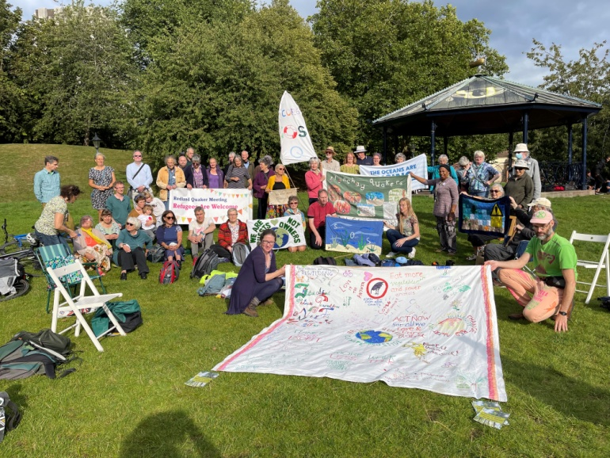All of our meetings have managed to continue Meetings for Worship during the pandemic and several are successfully running blended meetingsWe meet for AM business up to 6 times a year with an additional 2 conference days and another day reserved for an all age activity. This year the all age activity day was focussed on sustainability and included picnic lunches at various locations people could get to without using cars; we shared photos of these events with each other at the start of the afternoon session.

We continue to be challenged to respond more effectively to climate and ecological issues while holding on to the spirit and joy which binds us as a community. As with many other meetings we can find it hard to fill the roles our traditional structures demand and we are starting to explore the challenges and opportunities of the Simpler Meetings resources.

**North Somerset Area Meeting**

North Somerset Area Meeting (NSAM) was created almost 11 years ago from the western section of North Somerset & Wilts AM. We are a small Area Meeting, of 99 members and about 30 attenders, in three Local Meetings, each with their own Meeting House. Several Friends in our meetings have substantial care needs.

Claverham Quaker Meeting House is part of NSAM, but separately managed. It hosts a monthly Meeting for Worship attended by Quakers from a wide area.

NSAM holds four or five Area Meetings each year, currently “blended” from a Meeting House or Zoom only, with about 30 Friends attending regularly. We enjoy being small – we don’t have to travel too far and we know each other well.

Clevedon Local Meeting meets in a Victorian Meeting House in the hillside housing area of the town. 22 members are attached to the Meeting and most are busily involved. Several attenders have significant roles in the Meeting. The Meeting has close links with the community and participates in environmental campaigning and peace activities, working happily with other churches in the town.

Sidcot Local Meeting dates from 1690. The large Meeting House and burial ground are entirely surrounded by Sidcot School. An annexe forms a good small Meeting House for LM use. 57 members are attached to the Meeting but about 25 of them live elsewhere or have limited contact. Sewell House (run by Sidcot Friends Housing Society) is nearby.

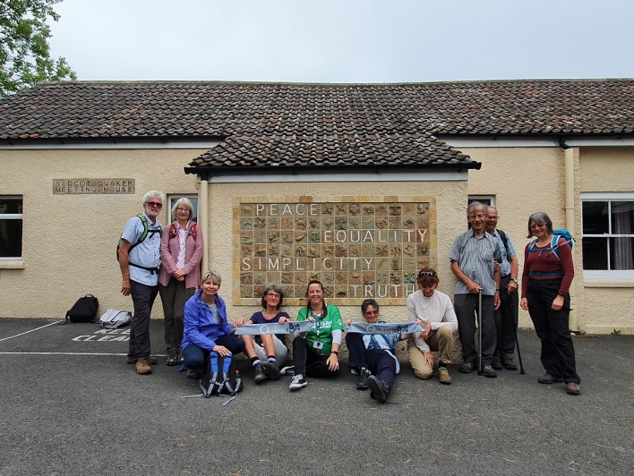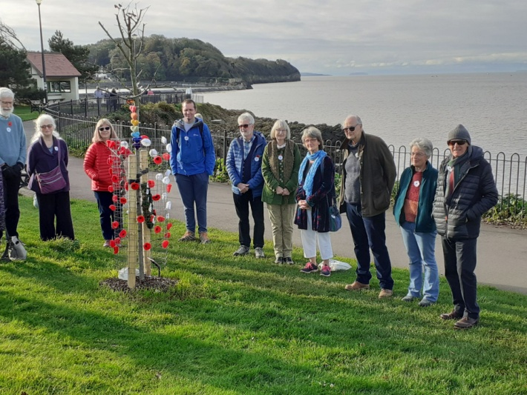Weston-super-Mare Local Meeting occupies a prime town-centre site in a purpose-built post-war Meeting House, which needs major refurbishment! The building is let to numerous community and religious groups (from Buddhist to Pentecostal Christian). The 20 members of the Meeting, with attenders, are actively working on building relationships in the Meeting. They have valued the support of the wider Quaker family.

**Mid Somerset**

The meeting covers a wide mainly rural area, with five regular meetings for worship using three established meeting houses. Meetings at these three are usually attended by twenty or more Friends and attenders. Shared interests are wide and variable.

Street Local Meeting has a lively membership and holds outreach exhibitions using film and art. Their ‘Quaker Connections’ Art Exhibition attracted 1,000 visitors and Quaker outreach films have received 16,000 views on YouTube. For five years the building was used by a Muslim group until they built a mosque.

Long Sutton Local Meeting publicly celebrated its tercentenary in 2017 with events, drama and talks. It actively supports a rural water project in Zimbabwe which it helped to found.

Wincanton Local Meeting has an area of garden used by charitable organisations for the welfare of their members.

Sherborne & Yeovil Local Meeting meet in a church hall in Sherborne, still hoping for renewed support from Yeovil Friends following lockdown.

The pandemic inevitably interrupted spiritual life. Meetings are gradually returning to former numbers following interim Zoom sessions. Area meetings are at full attendance and currently focus on issues emanating from BYM, Sufferings, and central committees. There is an active AM climate action group which recently organised public vigils for COP26 with plans for further events in 2022.

Developing friendships across our Area Meeting has been a priority, including three weekend residential Area Meeting retreats at Charney Manor (Oxfordshire) and Ammerdown (near Bath). In 2022 we plan an AM Away-day to Lyme Regis and a return Ammerdown weekend in 2023 with an invitation to Devon AM. Regular shared picnics involve invitees from neighbouring meetings.

Recent contact with nearby area meetings has focussed on financial management. A thriving Zoom book group aims to develop perspectives on other viewpoints and the historical backdrop to current events.

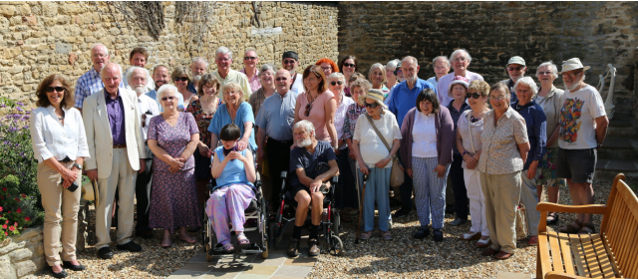

**West Wiltshire and East Somerset**

Our Area Meeting came into being about a decade ago, and we went for plain speaking when we named it. On the ground, we number just over 300 members and attenders and have Quaker meetings in Bath (34%), Bradford-on-Avon (21%), Chippenham (7%), Devizes (13%), Frome (20%), and Trowbridge (5%).

We are ripe for participating in the Simpler Meetings agenda. We rejoice in the children among us, but are conscious of our ageing profile as well as gradually declining numbers. Our communities have coped well during the pandemic and a few more distant Friends found us on Zoom—but we mostly turned inward to support ourselves. We need help to be more outward facing again, and to be visible to those people of less advanced years and more diverse backgrounds who would be glad to discover Quakers.

We have already embraced change. We created a more compact Area Meeting to cut travelling distances and carbon footprints. We streamlined our financial arrangements and we divided roles to spread the load. We reduced the administrative burdens on our Area Meetings in session and invite speakers to broaden their interest. Zoom allows us to welcome for worship some who had been unable to attend in person.

From having three meeting houses, we now have two, after taking the decision to sell our largest building, in Bath. We know that such actions can free Friends for greater spiritual commitment instead of managing premises. But we also need to explore how Quakers should have a visible—or at least findable—presence in our largest urban centre. Should we use the sale proceeds in Bath for the general benefit of the Area Meeting, or are there more important things to do? We have opportunities ahead. We are ready to share our development challenges. Come and join us!

1. Our Faith in the future is a document which sets out a shared vision of what Quakers in Britain would like their society to be like in the future. It is based on contributions from Quakers throughout the yearly meeting and was agreed by our representative body in 2015
2. Time percentages are given for guidance purposes and reflect broad expectations of how the post holder would spend their time over the course of a year. This may change over time following discussion and agreement between the post holder and line manager.