## 

# Application Pack

## Finance Manager

## Introduction

##### Sarah Chemonges

##### Financial Controller



**This is an exciting time to join us and make a real impact.**

## Introduction

Thank you for your interest in joining the Finance Team at Quakers in Britain. We support over 130 staff working in both our Charity and our hospitality business.

Quaker communities hope to be loving places where people find spiritual connection and can actively contribute to working for a better world for all.

We are a small supportive team of six who are looking to add a Finance Manager to our numbers to help deliver the accounting and finance services to organisation. It’s a busy environment but a lovely values-based organisation to belong to.

You will find in this application pack background information about the Quakers, salary and benefits of working for us along with the job description/ person specification for the post.

We look forward to reading your application.

Regards,

**Sarah Chemonges**

Financial Controller

### About Quakers

The Religious Society of Friends (Quakers) is a radical faith group with its roots in Christianity. It emerged in the mid-17th century as a group with no separate priesthood, and with a form of worship based in silence.

Quakers have been committed to peace, equality, simplicity and integrity throughout history, and are known for work to bring about social change over the years, such as on the abolition of the slave trade, the relief of suffering in wartime, improving living conditions for factory workers and the introduction of same-sex marriage.

You can read more about the story of Quakers at [www.quaker.org.uk/intro-quakers](http://www.quaker.org.uk/intro-quakers).

### About Britain Yearly Meeting

Britain Yearly Meeting (BYM) is the national umbrella organisation for Quaker meetings in Britain. We provide events and support services to nearly

500 local Quaker meetings across Britain, carry out peace, sustainability & social justice work on their behalf, and work to raise public awareness of Quakerism.

All Quakers in Britain are invited to come together at Yearly Meeting (the annual sessions of Britain Yearly Meeting), which meets to explore, through worship, the issues of concern to British Quakers, and to guide the work of the national charity.

We are a registered charity with an annual turnover of around £12m. Responsibility for the charity lies with the fifteen Trustees of Britain Yearly Meeting, appointed from among the Quaker community. We are based at Friends House (opposite Euston station in central London), which houses our central offices accommodating 150 staff.

You can download our Trustees Annual Report & Financial Statements here: [www.quaker.org.uk/annualreport](http://www.quaker.org.uk/annualreport)

The work of Britain Yearly Meeting is carried out through five departments:

* Quaker Life supports Quaker meetings in their life and worship, oversees Quaker outreach, provides training, and organizes events for children & young.
* Quaker Peace & Social Witness runs programmes supporting peace, economic justice, sustainability and criminal justice, through campaigning, training, placements, community empowerment and by supporting Quakers in local activity.
* Quaker Communication & Services promotes public awareness of Quakerism, provides advocacy, media, web and publications services to the organisation, and oversees fundraising from Quakers, Quaker meetings and Trusts.
* Quaker Finance & Property oversees the budget and finances of BYM, including our ethical investment portfolio and properties.

Our wholly-owned trading subsidiary, Quiet Company, operates Friends House as a major conference venue and runs the building facilities. The company also runs Swarthmoor Hall, a historic house with accommodation in Ulverston, Cumbria ([www.swarthmoorhall.co.uk](http://www.swarthmoorhall.co.uk)).

You can read more about the governance structures of the Quaker organisation in Britain here [www.quaker.org.uk/structure](http://www.quaker.org.uk/structur#e).

## About us

### Our Values

## Our values

How we act as Quakers goes together with what we believe.

Quakers don’t have a fixed creed because we have found that the search for truth can lead us to new expressions of values as well as confirming existing ones. We call these values ‘testimonies’. Today we focus on equality, peace, truth, justice and simplicity, and how they relate to one another.

Our testimonies encourage us to work for a more just, peaceful and sustainable world. It’s not always easy to live this way, but as Quakers we encourage each other to keep trying.

### Equality and justice

Quakers believe everyone is equal. This inspires us to try to change the systems that cause injustice and that stop us being genuine communities. It also means working with people who suffer injustice, such as prisoners of conscience and asylum seekers. We were campaigning for independent juries in the 17th-century, for marriage equality in the 21st, and for a range of things in between.

### Peace

that love is at the centre of existence and that all human life is of equal worth. It has led Quakers to refuse military service and work creatively for peace. This has ranged from practical work in areas affected by violent conflict to developing alternatives to violence at all levels. This could be personal or international.

### Truth and integrity

Quakers try to live according to the deepest truth we know, and we connect most deeply to this in the stillness of worship. This means speaking the truth at all times, including to people in positions of power. As we are guided by integrity, so we expect to see it in public life.

### Simplicity and sustainability

Quakers are concerned about excess and waste in our society. We want to make sure our use of natural resources is sustainable. We try to live simply and to find space for the things that really matter: the people around us, the natural world, and our experience of stillness.

The process of living out our faith is often called Quaker Witness – you can find out more about Quaker work by listening to our podcast: [www.quaker.org.uk/our-work/podcast](http://www.quaker.org.uk/our-work/podcast).

Britain Yearly Meeting is a national charity employing around 200 people. Its purpose is to work for, with and on behalf of Quakers in Britain.

## Working for Britain Yearly Meeting

### About our organisation

Quakers is the name often used for the Religious Society of Friends. Although we have our roots in Christianity, we also find meaning and value in the teachings and insights of other faiths and traditions.

In Britain there are about 20,000 Quakers. We have 500 local Quaker Meetings, grouped into 72 ‘area meeting’ charities. All these charities are affiliated to Britain Yearly Meeting (BYM).

Britain Yearly Meeting (BYM) is a charity, formally known as ‘Britain Yearly Meeting of the Religious Society of Friends’. The trustees are appointed by and accountable to British Quakers; and because this work is done for and on behalf of Quakers from the whole of Britain, the work we do is known as ‘centrally-managed work

### A Quaker workplace

We aim for our workplace to be consistent with Quaker values - broadly the same as most well-run progressive organisations. For example:

* We expect staff to respect each person regardless of age, race, religion, gender, transgender status, sex, sexual orientation, disability, marital or civil partnership status
* We avoid unjustifiable and unlawful discrimination in our employment practices
* We follow good employment practice, with clear and supportive line management
* We have a 1:4 ratio between the lowest and highest salaries
* We aim to be open and honest in all our work
* We avoid titles such as ‘Mrs.’ or ‘Mr’
* Very few jobs with BYM are restricted to Quakers, although about 1/3 of the staff are Quakers or linked to Quakers in some way.

### The Quaker way of life

The Quaker way is based on silent worship, as a way to help people connect directly to God. Quakerism began in Britain in the 17th Century. Its roots are in radical Christianity, although today not all Quakers call themselves Christian.

Quakers share a way of life rather than a set of beliefs. We seek to experience God directly, within ourselves and in our relationships with others and the world around us.

Quakers are ordinary people, who try to live their values they can. This leads many Quakers to work for a better world.

Values that are important to us include truth and integrity; simplicity; equality; peace; and sustainability.

You do not need to be a Quaker to worship with us at one of our meetings.

### You can find out more:

* From our website: [www.quaker.org.uk](http://www.quaker.org.uk).
* By reading Advice and queries which is an introduction to Quaker belief. Read it online at <http://qfp.quaker.org.uk>.
* By visiting the Quaker Centre at Friends House, which has leaflets and books, and volunteers who can answer questions.
* Or by requesting a free information pack from [www.quaker.org.uk/more-information](http://www.quaker.org.uk/more-information).

### Finance Team

## About the team

The Head of Finance and Resources, Financial Controller, Finance Managers & Finance Assistants comprise the Finance Team and finance and accounting support to Britain Yearly Meeting, Quiet Company and Friends Trust Limited.

The work of the Finance Team is essential to delivering our organisation’s strategy – Our faith in the future.

You'll work amongst an experienced and motivated group of accounting and finance professionals.

The team’s regular duties include:

### Accounts Payable

### Accounts Receivable

### Bank Reconciliation

### Balance Sheet Reconciliations

### Credit Control

### Post Journals

### Management Accounts

### Investment accounting

## Organisation chart

### Job purpose

## About this post

### To provide comprehensive support to the Finance Assistants

### Work as part of the Finance Team to ensure a high-quality service is delivered throughout Britain Yearly Meeting, Quiet Company and Friends Trust Limited.

### To build, development and maintain relationships with managers, staff, internal and external stakeholders

### 1. Key accountabilities and main tasks

**Transactions Processing and Reporting**

* Manage the day-to day operations of BYM, FTL and QC’s income and payments processing in a timely manner
* Oversee credit control and produce relevant reports
* Ensure all transactions and balances are accurately, appropriately, and promptly recorded on the charity’s accounting system (Business Central).
* Ensure all balance sheet accounts are reconciled and any differences are identified and resolved in a timely manner
* Manage cash-flow and treasury functions and prepare cash-flow forecasts as necessary
* Liaise with the bank regarding facilities and administration of bank accounts
* Maintain the fixed assets register
* Review corporate credit card statements and ensure appropriate use in line with policy
* Produce monthly management accounts and a brief commentary for the Board of Friends House Hospitality (London) Ltd. (turnover c£2m)
* Prepare the annual accounts for the Hospitality Company for review by the financial controller.
* Review and sign off reconciliations between the Customer Relations & commercial room-booking software to ensure that the information imported into Business Central is complete and accurate.
* Business partnering, supporting budget holder reporting and forecasting
* Ensure that the Rendezvous (Sales software) export to Business Central happens effectively, and the recharges and inter-Company transactions happen correctly
* Oversee the PDQ card payment systems for the Cafe, QC and Bookshop and support QC in the utilisation of effective card/cash payment and recording systems
* Meet regularly and report monthly to the QC CEO/GM on the financial performance of QC and make recommendations for improving financial performance, effective cost control and for addressing variations to budget
* Produce monthly payroll/labour cost reports for QC

#### **Payroll, pensions and VAT**

* Submit to, and review information received from the external payroll provider
* Create salary journal and HMRC payment run
* Administer the pension scheme and ensure contributions are submitted accurately and on time.
* Ensure appropriate VAT codes are used on transactions
* Prepare the quarterly VAT return for review by the Financial Controller

**Line Management**

* Create the conditions in which your team members can flourish individually, and as part of a team, to support delivery of BYM’s objectives.
* Support, direct, challenge and coach individuals to perform their best, holding them accountable for delivery of work to a high standard.
* Be a model of good practice and practise good self-management and accountability to their line manager.
* Enable your team to plan and work collaboratively with partners in the rest of the organisation
* Being promptly available as needed to your team.
* Agreeing working arrangements, and monitoring workload.
* Monitoring flexible working, TOIL and annual leave through SelectHR.
* Setting of team objectives that are consistent with the Operational Plans.

**General requirements**

* Undertake all mandatory training on key areas of work including safeguarding and data protection.
* Ensure compliance with statutory requirements and local protocols including for example the General Data Protection Regulation (GDPR) and confidentiality policies, organisational policies, and Health and Safety at Work requirements.
* Be sensitive and caring to the needs of others, promoting a positive approach to a harmonious working environment and contributing to a healthy, happy workplace in which everyone feels welcome and able to contribute

### 2. Intellectual demands

* Analytical planning, prioritising and project management skills.
* Ability to understand complex information, summarise it and to present it to a range of audiences.
* The ability to respond flexibly to changing circumstances.
* The ability, having identified relevant previous experience, to adapt it usefully to the current situation.
* A high level of attention to detail and the ability to work quickly and accurately under pressure.
* An up-to-date understanding of United Kingdom Generally Accepted Accounting Practice and the Charities Act 2011 as they apply to BYM and/or the Hospitality Company.

### 3. Judgements

* The post holder is expected to be largely self-directed and is regularly expected to make operational, managerial and professional decisions based on his/her knowledge and judgement.
* Setting and managing timetable priorities for monthly, quarterly and annual accounting cycles so ensuring the optimal balance between timeliness and data accuracy.
* Adjustments and transfers to accounting entries in order better to present the underlying substance of all financial transactions.
* Responsibility for authorising or withholding payments from BYM’s and the Hospitality Company bank accounts.

### 4. Physical Demands & Co-ordination

There are no unusual physical demands.

### Other responsibilities

* To undertake duties and responsibilities commensurate with the post
* Responsible for ensuring that BYM’s Safeguarding Policy is adhered to in all aspects of the role
* To undertake duties and responsibilities commensurate with the post
* Responsible for ensuring that BYM, FTL and QC’s Safeguarding Policy is adhered to in all aspects of the role
* Responsible for ensuring that BYM, FTL and QC’s Equal Opportunities Policy is adhered to in all aspects of the role
* Responsible for ensuring that BYM, FTL and QC’s Health & Safety Policy is adhered to at all times
* Responsible for ensuring that BYM, FTL and QC’s commitment to sustainability is adhered to in all aspects of the role
* Responsible for ensuring that Britain Yearly Meeting’s Staff handbook is adhered to at all times.

### Essential knowledge

## Person specification

* Up to date knowledge of UK Generally Accepted Accounting Practice and charity SORP.
* Communicating effectively on financial issues with non-finance stakeholders.
* Knowledge of and sympathy with Quaker values.
* Understanding and experience of the charity sector.

### Essential qualification

### Full professional accountancy qualification (ACCA/CIMA/ACA) or QBE

### Essential experience

* Proven experience in managing and leading payments and income processing for a medium sized charity, preferably with a commercial arm.
* Proven experience in communicating both written and verbally with senior managers and other non-finance stakeholders
* Experience of managing and leading a small team of staff
* Proven ability of building and maintaining relationships with internal and external correspondents
* Proficiency in Microsoft Office products including Excel to an advanced level
* A thorough understanding of the underlying concepts and principles of finance including legislative and/or regulatory frameworks
* Experience and knowledge of VAT, FRS 102 SORP, Gift Aid
* Working knowledge of complex financial management systems e.g. Business Central
* Demonstrate awareness of, and sensitivity to, issues of equality, diversity and inclusion and a commitment to the unique value of the individual in all aspects of the BYM’s life

### Essential skills

* Ability to work collaboratively with colleagues, and others, including volunteers
* Professional and positive approach, with a commitment to professional development and self-improvement
* First class organisational and administrative skills; systematic in approach to tasks, with attention to detail
* Proactive, self-motivated and able to work with minimal supervision
* Ability to work flexibly as part of a team
* Ability to remain calm when under pressure and employ tact and diplomacy in difficult/sensitive situations
* Excellent interpersonal and communications skills including the ability to relate well to people on all levels with sensitivity, tact and diplomacy

### Desirables

* Working experience of Business Central and Jet Reporting.
* Knowledge of Hospitality business financial management

### Salary

## Salary & benefits

£45,673 – London

£38,823 – regional

### Location

Friends House, NW1 or Quakers in Britain Yorkshire Centre, LS2. Staff can work at home some of the time by agreement.

### Hours of work

35 hours per week. We recognise that balancing the pressures of work and home life is often an important factor in taking a part time role. We can be flexible in agreeing how the hours are arranged across the week.

### Flexible working options

While the role is London-office based, we are open to discussions about flexible working patterns such as working from home or compressed working patterns.

### Holiday

27 days a year plus bank holidays and three days for Christmas closure.

### Subsidised café

We have an on-site café which provides subsidised meals as well as a bookshop selling ethically sourced goods.

### Cycle to work scheme

We offer a cycle to work scheme which helps you save money on a new work bike and spread the cost of the bike over monthly tax-free instalments.

### Annual Season Ticket Loan

We will provide with a loan of up to £7,500 to cover the cost of your season ticket repayable in 11 monthly instalments.

### Sabbatical scheme

Staff are able to take a nine-month unpaid sabbatical leave after five years’ continuous service.

### Pension scheme

Quakers have a generous pension scheme where we contribute 8% of your salary and you contribute 3% of your salary. You have the option to increase your contributions should you wish and to pay your contributions via salary sacrifice.

### Sick pay scheme

We have a very generous sick pay scheme:

If you have less than 12 months service, you are entitled to full sick pay for 3 weeks followed by three weeks at half pay.

After 1 years’ service, you are entitled to full sick pay for 3 months followed by 3 months at half pay, subject to a maximum of six months since the start of your service

After 4 years’ service you are entitled to full sick pay for six months followed by six months at half pay, subject to a maximum of 12 months.

### Private Health Insurance

If you are off work due to sickness for more than 52 continuous weeks you will be eligible, subject to requirements of the scheme, to sick pay.

### Employee Assistance

Quakers offers access to an independent, confidential employee assistance programme, which is available 24 hours a day.

### Family Friendly Policies

Our family friendly policies give enhanced maternity and adoption leave. Once you have one year’s service by the 15th week before your baby is born or you adopt, you will be entitled to six weeks at full pay, 20 weeks at half pay and 13 weeks at SMP.

Apply on line at [www.quaker.org.uk/jobs](http://www.quaker.org.uk/jobs).

The closing date for applications is:

5pm on 18 January 2022.

The principles of equality and diversity are important to Quakers in Britain in all aspects of its work. We encourage you to fill in our diversity monitoring form when applying. The information you provide will helps us to monitor and refine our employment practice and respond to the needs of the diverse range of people that the organisation comes in to contact with.

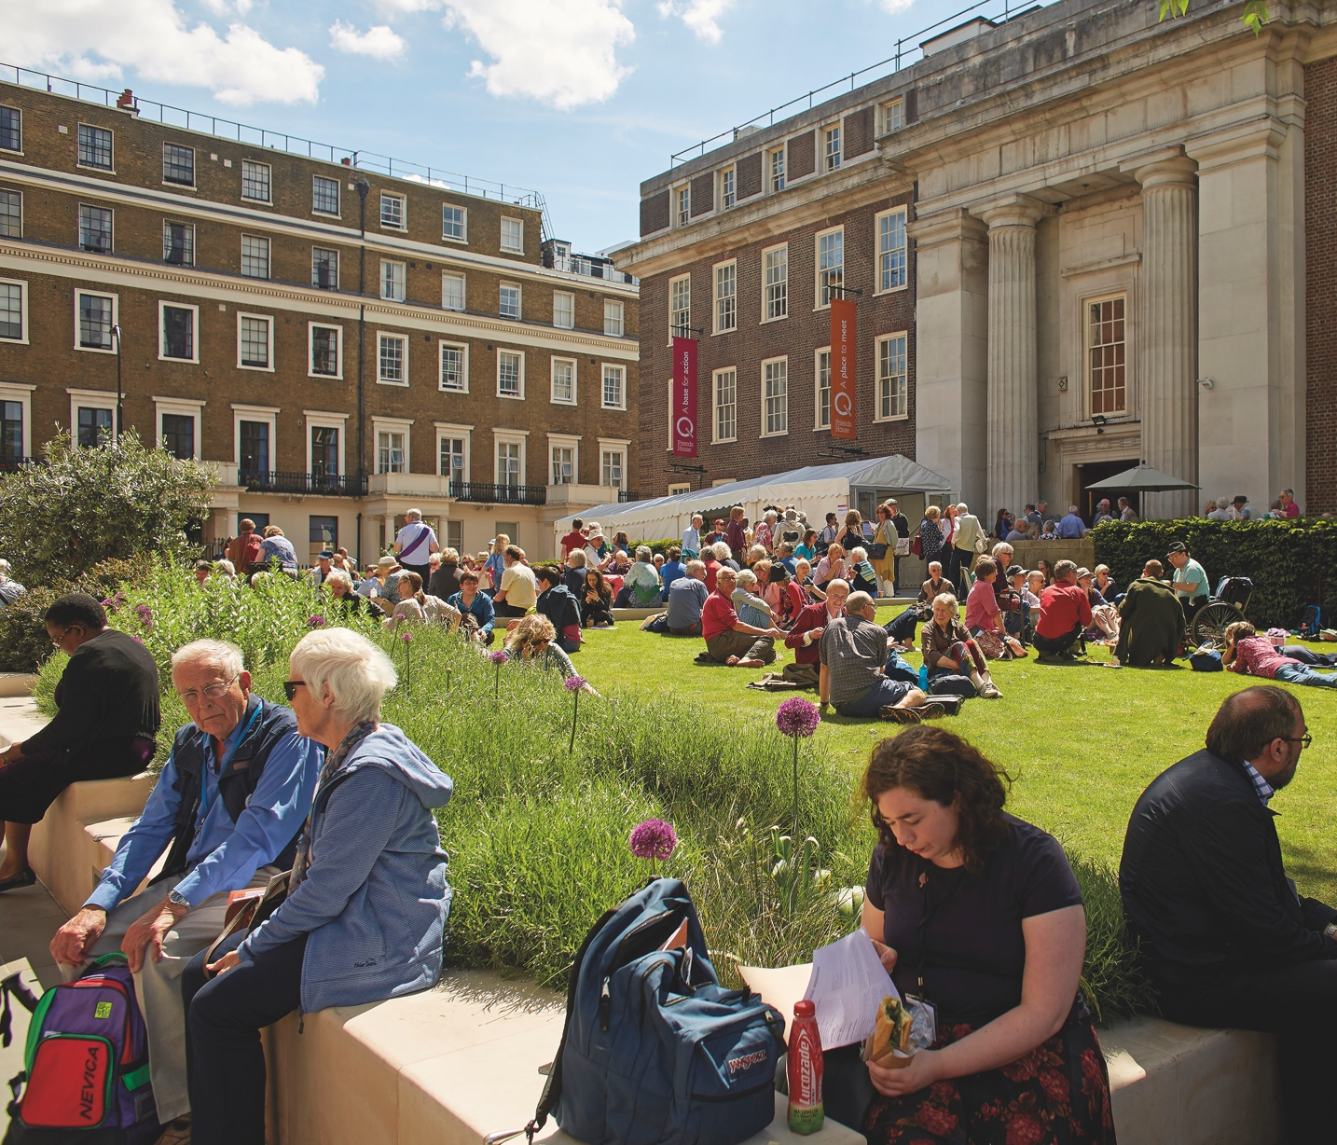We will consider your application immediately after the closing date and get in touch with you as soon as possible.

Interviews will be conducted by Financial Controller, General Manager of Quiet Company and a Trustee, on 20 January 2022.

We do not send individual acknowledgement of applications due to the high volume of applications we receive and we only contact candidates who have been shortlisted for an interview. If you do not hear from us within two weeks of the closing date your application has not been successful on this occasion.

## How to apply