Worksheet: Match each message to the correct remembrance symbol
Remembering Animals killed in war |  | 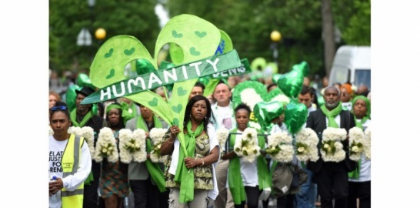
Remembering all people including civilians killed in war |  | 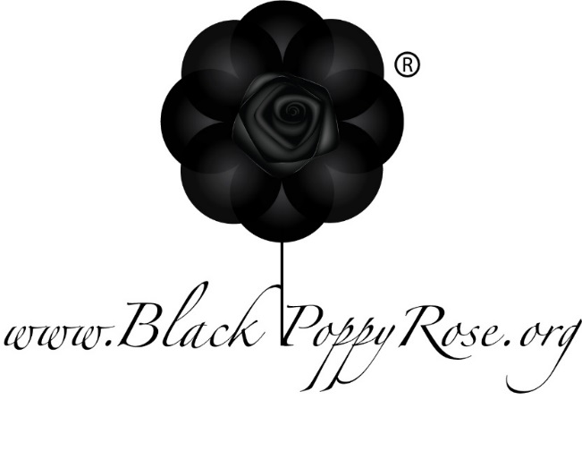
Remembering British and British Empire troops killed in war |  | 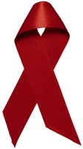
Remembering black people killed in war |  | 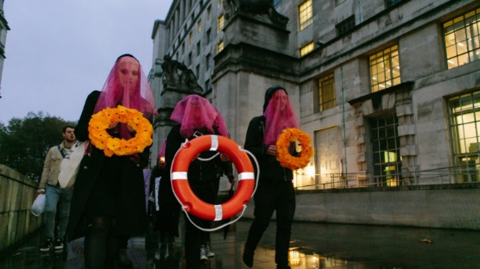
Remembering people who have died because of HIV/AIDS |  | 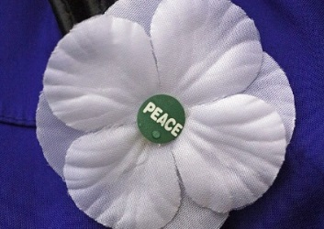
Remembering refugees and migrants killed trying to escape war |  | 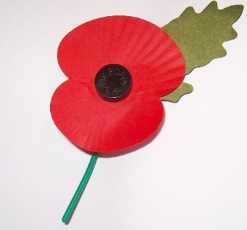
Remembering people killed in the Grenfell Tower fire |  | 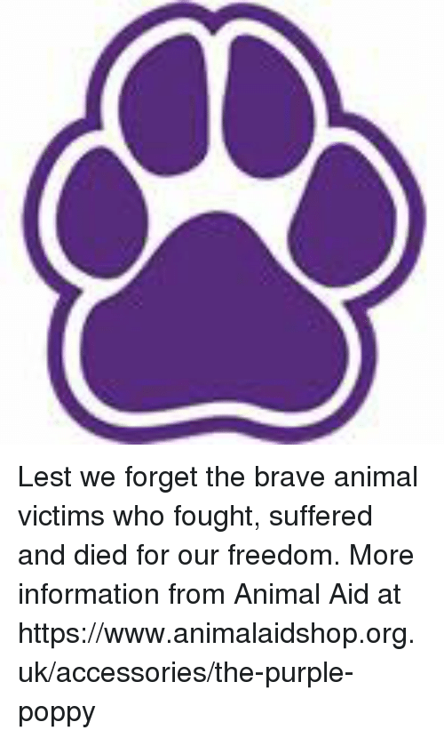

Answers and information
The purple paw is for Remembering Animals killed in war.
It used to be a purple poppy. It’s sold by a group called Animal Aid. 8 million horses and countless mules and donkeys died in World War I. Dogs, camels and pigeons and many other animals have all been used in human Wars.
The White Poppy is for all people including civilians killed in war. It represents remembrance for all victims of war, a commitment to peace and a challenge to attempts to glamorise or celebrate war. White poppies were developed in 1933 by the Co-operative Women's Guild to say “no more war”. The twentieth century saw a massive growth in the number of civilians killed in war. Today it is promoted and sold by the Peace Pledge Union. | 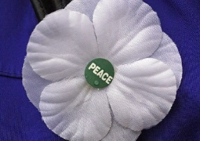
The Black Poppy Rose remembers black people killed in war. It highlights the way African/Black/West Indian/Pacific Island people are often left out of history. For example there were many non-white soldiers fighting for Britain and at home there were anti-black ‘race riots’ in 1919. Black Poppies was the title of the book telling black people’s stories from World War I. | 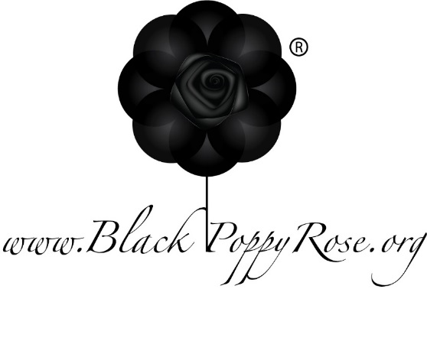
The Red Poppy was created to remember British and British Empire troops killed in war. It was inspired by the fields of red that sprung on the battlefields after World War I. After the Empire ended, it was used to remember commonwealth soldiers. Originally this was in memory of World War I, but it now represents losses in all wars. They are sold by The Royal British Legion | 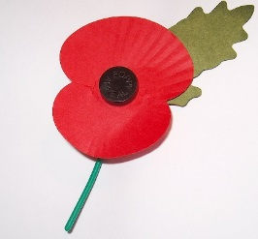
The orange life ring remembers refugees and migrants killed trying to escape war. Between 1993-2018, 34,361 men, women and children who perished trying to reach Europe, many of them very recently. A life ring was chosen because of the many refugees who have drowned crossing the sea. In 2017, Lesbians and Gays Support the Migrants placed life rings and orange poppy wreaths on the cenotaph for Remembrance. | 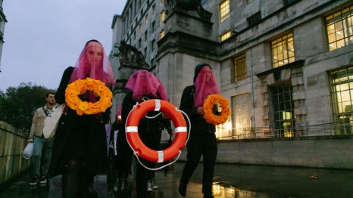
The green heart symbol is used to remember 72 victims killed in the Grenfell Tower fire in 2017. The word Grenfell is old way of saying "green field", so they chose the colour. It is meant to be a symbol of "hope, unity and love - and to remember those that were lost". | 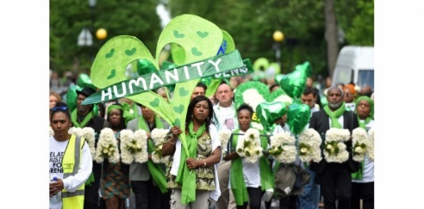
The Red Ribbon is the symbol of AIDS Awareness. Inspired by the yellow ribbons worn for American soldiers serving in the Gulf war, artists in 1991 chose to create a red ribbon to symbolize support and solidarity for people living with HIV and to remember those who have died from AIDS-related illnesses.

