Epistle from Britain Yearly Meeting, held at Friends House, London on 24-27 May 2019

Loving greetings to Friends everywhere,
Our themes have encouraged us to look through the lens of privilege at climate justice, and at diversity and inclusion. The opening session was one of tenderness and love. We heard about the need to be a trusting and trusted community, sharing our insights and experience, perhaps bringing to light what has been hidden. In their introduction, our Clerks acknowledged that we are confronting difficult and potentially alienating topics. There is a risk of becoming mired in introspection and failing to address the challenges presented to us.
Each of us is at a different stage of this journey and has different understandings of the issues involved. The word ‘privilege’ has been used in two distinct ways this weekend: as a blessing we experience and as the unearned advantages a person can inherit from birth and/or accumulate over time. This has brought some frustrations. Our identities are complex and multifaceted. We need to be aware of the ways in which we can simultaneously have, and lack, privilege.
The words of Junior Yearly Meeting (JYM) frame the challenge we face:
“We recognise the exclusion we may create is not intentional but it doesn’t mean we aren’t responsible for it. There is a feeling Quakers are passively inclusive. Our testimony to equality makes us complacent.” (from JYM 2019, Minute 1)
We need to be gentle with Friends who feel uncertain about how to engage whilst moving with a sense of urgency, knowing that these issues are an everyday source of pain for some of us.
Over 1,200 Friends have participated. Our twin themes have been woven together in main sessions, parallel sessions, special interest groups, programmed and unprogrammed worship, across different age groups and in the buzz of our shared spaces. The Children’s programme focused on Caring and Including. Exploring the themes worshipfully through dance and singing has been a gentle way to make friends and build our spiritual community.
During our time together, we’ve shed tears of joy, of emotion and of sadness. We are thankful to Friends who were able to share the riches and vulnerabilities in their life stories. Listening to these stories in the Spirit helps us to reflect on how we need to change.
“There is nothing that age, experience and status can do to pre-judge where and how the Light will appear”. (Quaker faith & practice, 23.32)
We recognise that the Light may not be warm and comfortable but be a spotlight exposing our vulnerability, complicity and fear. It is from such discomfort, even being broken, that spiritual growth can come alive. We want to stay with the struggle and hold the tension.
Guilt and shame emerged as strong themes in our opening worship: guilt for what we’ve done and shame for who we are and for what we’ve inherited. By sitting with overwhelming feelings we have the hope of transformation: anger and fear can become passion and love. Helplessness can trigger us to learn. Accountability and responsibility can guide us to make changes in our lives. In the Swarthmore Lecture, “On earth as it is in heaven; the kingdom of God and the yearning of creation”, we were challenged that the more we give ourselves over, the more we are given.
We have heard how our sense of being ‘Quakerly’ can itself be a barrier. As Quakers, we are not called simply to be good - how instead, in our frailty, are we called to live faithfully?
“Somewhere beyond right and wrong there is a garden. I will meet you there.” (Rumi)
Let us begin to understand what it means to be in unity with others and with the whole of creation, acting out of love rather than duty or fear. It’s all about Love.

Signed in and on behalf of Britain Yearly Meeting
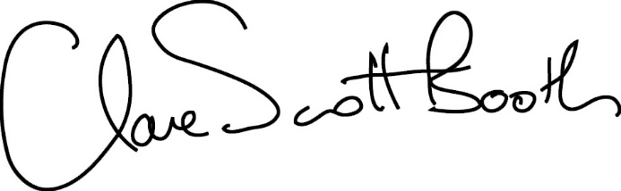

Clare Scott Booth
Clerk

