Using the #EverydayMilitarism poster
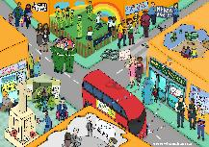
The EverydayMilitarism poster shows examples of militarism and its effects on British life. You can display it for people to find or use it to stimulate discussion. Everything shown is “real” - something that does happen on the streets of Britain.
Download the image and view an interactive version of this poster at: www.quaker.org.uk/resources/free-resources/teaching-resources-2

Suggested activities
These activities are all about responding to the image without the accompanying information- once you’ve got the discussion going, you can unfold the bottom of the poster to find out more.

Quick spot – pair work
Give the poster to a pair: one person can see the sheet- the other should have a pen and paper.
The first person has 60 seconds to describe as many of the things they can see as possible while the other person scribes. You can compare the lists with other pairs afterwards- who got the most? What did they miss?

Colour coding
In pairs, use three colours of sticker on the poster to indicate:
- Things that make war more likely
- Things that make war less likely
- Things you need to know more about
Discuss what you’ve found – is there agreement? Is there another way to see it?

Simple discussion
Give the poster to small groups for discussion:
Prompt questions you could ask:
- What is happening?
- Why is this happening?
- What might the effect of this be?
- How do these things connect?
- Does anything surprise you?
- Can you think of other examples of militarism not shown here?
You can also use the accompanying handout to find further information

Silent conversation
This annotation activity is a chance to explore the topic in detail.
Stick copies of the #EverydayMilitarism poster in the middle of big sheets of paper.
Divide into groups of 2–4 and give each group a poster and give a different coloured pen to each person in the group. In silence, each group should look over the poster. As they examine it, they should write comments and questions.

Prompt questions you could ask: What is happening? Why is this happening? What might the effect be? How do these things connect?

Anyone can add further comments and questions to those of others, making it a conversation. After a while, encourage people to move around the room to look at other groups’ posters and join other conversations.
ALL IN SILENCE!
Finally, ask someone to describe some interesting points people shared on each sheet.
You can also use the accompanying handout to find further information

Philosophy discussion
You can use this poster as the stimulus for a “Philosophy for Children” (or adults) discussion. Having shared it, ask the participants to generate their own “big questions” to discuss
Read more about structuring this kind of discussion here: p4c.com/about-p4c/teachers-guide/

Look online
Check out #EverydayMilitarism on social media such as Facebook or Twitter. Can you add other examples online or offline?

Handout:
#EverydayMilitarism Handout Page 1

#EverydayMilitarism - What’s going on?
Download the free workshop outline and an interactive version of this poster at www.quaker.org.uk/peace-education

Under 18 recruitment
The UK and Belarus are the only countries in Europe to recruit into the armed forces at age 16. Most nations do not recruit until age 18. Younger recruits in the British army tend to face more risks and problems when they leave.
Discuss: What should the UK recruitment age be?
More: Beforeyousignup.info | www.child-soldiers.org/uk |www.army.mod.uk/careers

A public show
Government policy has been to make the armed forces more visible to the public since 2009. That can include simply wearing a uniform off-base, recruitment stalls, parades, or displays at sporting events. Often young children are invited to hold guns or sit in military vehicles. Armed Forces Day began in 2009 “to show your support for the men and women who make up the Armed Forces community”.
Discuss: What effect does seeing more about the armed forces have on the way we think?

UK deaths in war
Although they tend to experience fewer deaths than people from the countries they fight in, Britain’s soldiers get killed in war.
- 456 deaths in Afghanistan 2001 – 2014
- 179 deaths in Iraq 2003-2009
In Britain, soldiers’ bodies were transported through the town of Wootton Bassett in memorial parades until 2011.
Discuss: Why do you think people lined the streets to see the memorial parades?

Charities helping former soldiers
According to reports, at least 13,000 former members of the armed forces are homeless in Britain today. Many also suffer with post-traumatic stress disorder and struggle with addiction. People from the British armed forces often get support from charities to deal with these problems.
Discuss: Should it be left to charities to help look after former members of the armed forces hurt by war? |
More: www.forceswatch.net

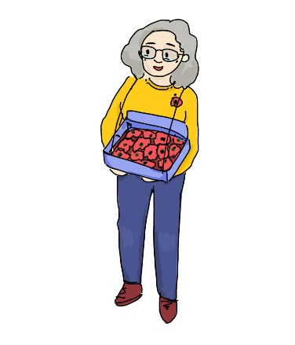
Poppies and Remembrance
#EverydayMilitarism Handout Page 2
Poppies are worn around 11th November, Remembrance Day. The white poppy is a call for peace in memory the dead of all countries, military or civilian. The red poppy is worn to remember Britain and commonwealth military war dead.
Discuss: If you spend 2 minutes in silence for Remembrance, what do you think about?
More: www.ppu.org.uk/whitepoppy

War and peace
The United Kingdom has been at war every year since 1914. In 2018, British forces were fighting in Iraq and Syria, with a total of 25 operations around the world. In 2018, there are 4 major ones (more than 10,000 deaths in the last year) and 14 other conflicts that have killed more than 1,000 people so far.
Discuss: Can we work to end war? How?
More: www.qcea.org/peace/research-project

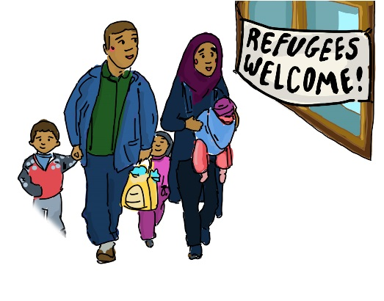
Fleeing war, seeking safety
In 2018 more than 65 million people are displaced today – about the same number of people that live in Britain. Many are refugees who have fled to other countries – most are still somewhere in their own country. According to the UN, 86% stayed in poorer countries - very few reach the United Kingdom or other rich countries.
Discuss: What might a person who has fled war feel about Armed Forces Day?
More: www.unhcr.org/uk/teachers-toolkit

Selling weapons
More weapons are being sold around the world each year. The UK is the sixth 6th biggest exporter of weapons. In 2013-17, most of those weapons were sold to Saudi Arabia (49% of all sales), Oman (14% of all sales) and Indonesia (9.9% of all sales). Many of the countries the UK sells weapons to have bad human rights records. Roughly 55,000 or 0.2% of UK jobs come from arms exports. The world’s biggest arms exporter is the USA (34%).
Discuss: What effects can selling weapons around the world have?
More: www.caat.org.uk

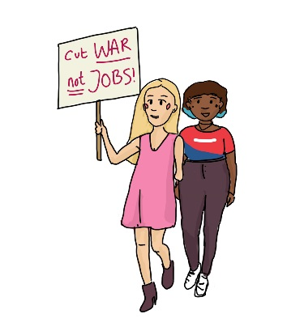
Public opposition to war
#EverydayMilitarism Handout Page 3
There have been protests to Britain’s wars for centuries. In 2003, over 1 one million people marched through London against the UK invasion of Iraq.
Veterans for Peace UK say “War is not the solution to the problems we face in the 21st century”. Their members used to be in the armed forces. The oldest members fought in World War II and its youngest members in Afghanistan.
Discuss: why do you think members of Veterans for Peace have thrown away their medals?
More: www.stopwar.org.uk/ | vfpuk.org

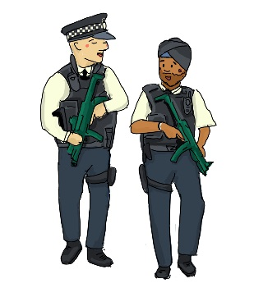
Armed police (armed police image)
Having fallen for several years, the number of armed police officers is increasing to about 7,000.
Discuss: What is the difference between the police and the army? Do they make people feel safer?
More: netpol.org

Computer games and toys
Computer games and toys are often military themed, sometimes created with the support of the armed forces. The British military releases official toys he America’s Army game was used to recruit soldiers, but no players ever die. Some military drone pilots have compared their job playing a video game.
Discuss: What effect do military toys and games have on the way we think about war?

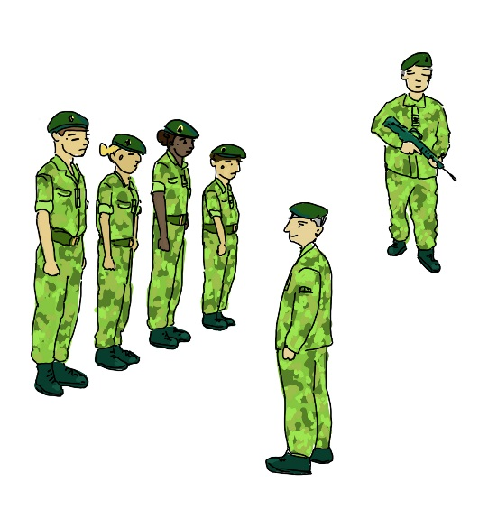
Military involvement in schools
With programmes like cadet force expansion in schools, career talks and Troops to Teachers, the Government has been encouraging military involvement in schools.
Discuss: What might be the effects of more military involvement in schools?
More: www.unseenmarch.org.uk

