# New economy reading group programme

# Session plan: Booklet 7 – building the new economy

*A note on how to use these session plans:*

This plan is written for session facilitator(s) rather than for the whole group.

Facilitators are the people hosting and running the meeting. They do not need any expertise whatsoever on economics. They will also take part in all meeting activities where possible.

This plan is intended as a guide to help you run useful sessions. If parts of the plan are not relevant to your group, then feel free to discard or change them! Do whatever works best for your group.

**Agenda outline**

*This plan contains different options for how to structure the session. There are some recommended introductory and closing activities. You can pick and mix activities from the middle ‘exploratory’ section. There are also optional ‘reflection on action’ activities if you think your group wishes to explore the practical steps that they can take out in the world to build the new economy in relation to markets and public/private provisioning.*

*Ultimately, this final booklet is really a chance for your reading group to get excited about what you can do next as a team to help build the new economy. You don’t need all the answers now, but you can explore little by little where you might be heading together.*

*At the end of the session, you may want to think about when you’ll meet up next to see how the booklets as a whole series have shaped your understanding of the economy. We will send a final session plan in the new year to support you with this discussion.*

**Example:**

|  |  |  |
| --- | --- | --- |
|  | **Activity** | **Timings** |
| Introduction | 1. Welcome | 5 mins |
| 2. Introductions | 5 mins |
| 3. Check in | 10 mins |
| 4. Recap from last session | 5 mins |
| Exploration | 5. Worship sharing | 30 mins |
| *Tea break* | 10 mins |
| 6. Questions for discussion / Common roots / One-one practice | 10 mins |
| 7. Examples and inspiration / taking action | 15 mins |
| Action | 8. Our power – the role for Quakers / Spiritual activism | 20 mins |
| Closing | 9. Closing | 10 mins |

Total time: 2 hours

## Materials needed

Tea, coffee / refreshments (if you decide you want them)

Paper copies of Booklet 7: Building the new economy

Paper copies of the previous 6 booklets (optional)

Paper copies of *Principles for a new economy* (optional)

Print outs of exercises (optional)

Flipchart paper and pens

Post it notes

## Session plan

**Introductory activities**

1. **Welcome (3 minutes – not including worship time)**

You may want to offer people tea and coffee as they arrive. Make sure everyone has a comfortable place to sit. Chairs should be arranged in a single circle.

***Silence / worship (optional)***

At the start, thank everyone for coming, introduce yourself if anyone doesn’t know you and begin the silence / worship.

1. **Introduction to the session and housekeeping (5 minutes)**

Welcome everyone, and thank all those involved in organising the session. If there is anyone new in the room (who wasn’t at the first session), suggest that everyone in the room goes round the circle and introduces themselves briefly (saying their name and one brief detail, such as where they’re from).

Once this is done, outline the agenda for today (see agenda outline above). Explain that the aim of the session is to have a chance to discuss some of the ideas in the sixth new economy booklet, *Building the new economy.*

It is assumed that people will have this booklet in advance.

If there is anyone new in the room (who wasn’t at the previous sessions), emphasise again that no prior economic knowledge whatsoever is necessary and that you want everyone to feel welcome, even if they don’t have experience of discussing subjects like this. You can suggest that if anyone thinks they might have practical difficulty reading the booklets they can talk to you after the session to think of ways to work around this. Large print copies of the booklet are available from Friends House (email [neweconomy@quaker.org.uk](mailto:neweconomy@quaker.org.uk)).

***A record of discussion***

Some meetings have decided to keep notes of their discussion, in order to record their responses to the ideas in the booklets, and add ideas of their own. If your group has found examples of spiritually led new economy practices, we’d love to hear about these. You can share examples by sending them to us at [neweconomy@quaker.org.uk](mailto:neweconomy@quaker.org.uk) or share them on our private online new economy forum on Loomio: https://www.loomio.org/invitations/adfc4d5c2f5c9b416cf2

You may want to propose to the group that your reading group could also keep records or produce some kind of response to the session. If so, you could arrange at this point for someone to take notes or write up the session.

**Exploratory activities**

1. **Check in (10 – 20 minutes)**

Ask everyone to go round and feedback briefly on how they found the booklet, including any questions they have relating to its content. You could add these questions to notes about the session (if you’re keeping them). You may wish to ask participants to limit their feedback to one or two minutes each (see facilitation tips).

1. **Reflection on last session (5 – 15 mins)**

* Recap briefly what you discussed in the last session (5 mins max – don’t get in to discussion about any of the specific issues)
* If anyone committed to specific action from the last session (e.g asking your meeting can help register community assets in your local area) invite them to feedback what they did and how it went.
* Ask if anyone else has made changes or taken any action around the commons, or encouraging support for co-operatives and public ownership of Earth’s resources.

1. **Worship sharing (optional) (30 – 60 minutes)**

See accompanying guide to worship sharing in the email.

Prompts for contemplation could be:

* Share your responses to the booklet
* Share your response to the subject in light of Quaker testimony

But feel free to choose your own prompts or ways of framing the worship.

**Meeting for Sufferings Statement –**

*“We ourselves are part of the problem. Many are too rich. We damage the land, the sea, and all living creatures. We are stealing the future. Change is urgent. We need to recognize our own selfishness and privilege: to be changed ourselves, to live as if the Kingdom of God were already fulfilled.*

*When we engage with the brokenness of the world, one of our tools can be our willingness to listen: to the vulnerable, to each other, to those with whom we disagree, and to the leadings of the Holy Spirit. This will enable us to work alongside others powerfully, telling the truth of what is wrong in the world. Sometimes listening will lead us to stillness, at other times to practical action. In all things the Spirit will direct us.*

*Working with others gives us strength. Their insights may lead us to see our own shortcomings. We can also hold conversations with those in positions of authority and influence.*

*Ours may be a supporting role. We may be called to comfort and uphold, to practise small kindnesses, to admit our own weakness, and to undertake practical tasks which enable others to act. Sometimes being there is enough.*

*Action may demand courage. This may mean taking part in public protests or acts of disobedience. We may be led to challenge rooted injustices and to use our energy to bring about radical change. Jesus overturned the tables of the money-changers in the temple. He taught that the blessed community was formed of the poor, the hungry and those suffering loss or persecution. [Luke 6:20-22]”*

If possible, ensure there are a few copies of the statement for participants to read through.

This statement was adopted by Yearly Meeting Gathering in 2017.

How does this statement connect with your readings of the New Economy series?

Spend a few moments considering the final sentence.

Share thoughts on how to ‘we ourselves are part of the problems’

1. **Questions for discussion (optional) (15 – 90 minutes)**

Read out the questions that are included in the blue boxes in the booklet (see list in appendix) or distribute print outs of the appendix to participants. Ask participants to identify any questions that they would like to discuss.

Participants could break into pairs or small groups to discuss questions and then feed back to the wider group. Or you can work through the questions identified as a whole group. In this case, ask that Friends be mindful of the balance of participation (see facilitation tips also included in the email).

OR

**Finding allies using one-to-ones -** What is a one-to-one?

When we think about meetings, we often think about agendas, minutes, and outcome that we need to achieve by the end. A one-to-one is almost the direct opposite of that. “A one-to-one is a short (40-45 minute) conversation between two people, which opens up their stories and their passions. When you come away you have a greater sense of what gets each other out of bed in the morning, what makes them tick, what is most important to them.” (*Faithful Citizens, p.62)* It is a meeting with someone else that you often come to with an open mind. The aim of a one-to-one is to: Identify each other’s interests; find common interests; identify issues to work on together.

**It is:** Intentional**,** Mutual and Short

**It isn’t:** Chit chat, Superficial, Pastoral, Therapy

In order to have a successful one-to-one you’ll want to practice:

**Do:**

* Active listening
* Probe (ask why?)
* Take some risks

**Don’t:**

* Pry
* Interject
* Talk too much

OR

**Common roots**

ROOT CAUSES

A *root cause* is underlying force in society that, at the fundamental level, explains why the system’s natural behaviour produces the problem symptoms rather than some other behaviour.

**Paired activity: What are our common roots? *This exercise will help you to develop an understanding of your common cause and will introduce you to systems thinking.***

* In pairs or individually, identify a problem that you want to explore – it could be “lack of good housing?” or “fossil fuel economy” or “precarious work practices”
* Draw an outline of a tree on an A3 piece of paper
* LEAVES - Begin to grow your tree by adding leaves. This represents the “outcomes” that exist within society because of this problem – they are things that we see

*e.g homelessness, violence, mental health, environmental destruction*

* BRANCHES - Within the branches, write down the policies/groups that influence and create these outputs symptoms

*e.g: banking deregulation, privatisation of land, closure of job centres, increase use of food banks*

* TRUNK- Down the trunk– find out what institutions create and uphold these policies / groups

*e.g religious, financial sector, media, education etc*

* ROOTS - Underground, within the roots – begin to ask what forces motivate or incentivize these institutions to act in that way

e.g *ideologies, ideas, powers*

To complete this exercise, share your trees with one another and explore the similarities and connections between the different issues you’ve looked at.

SYSTEMS CHANGE

By *systems* we mean that the work we do tackles, in one form or another, the dominant economic and political system we live in

A project or action concerned with systems change might address dominant forces in our society, such as patriarchy, white supremacy, elitism.

1. **Examples for inspiration (optional)**

A chance for participants to share examples of effective actions or inspiring movements for change, or reflect on the examples in the booklet.

Question: Which real-life examples from the booklet most inspired Friends? Do people know of other organisations locally who are thinking about local economies and economic transition?

**Taking action (optional)**

This section is a chance to ask friends about their personal experience of taking action.

1. What kind of actions, campaigns or projects have you engaged in in the past?
2. What role have you taken? (Leading, supporting, critiquing, evaluating)
3. How do you hear about campaigns and actions? Where do you get your inspiration from?
4. Who is part of your group? Who is not there that needs to be?
5. How do you feel you can improve your engagement in local projects to better support building the new economy?

These questions are a chance to reflect on a potential actions that friends can take in their local community and can be explored further below.

**Reflections on action**

1. **Our power – the role for Quakers**

This exercise focuses particularly on the discussion point ‘What role could Quaker meetings and meeting houses (if applicable) play in building the new economy?

This works best as a whole group exercise.

Use a large sheet of paper, such as a flip chart paper.

Encourage the group to contribute responses to the questions in these categories.

**Interests –** was there a particular booklet that you were inspired or interested by?

**Needs** – what do you know of the area you live in, and its community and what is most needed in this area (housing, food, energy, local businesses, effective public services, transport) and how can we shape these to support the new economy?

**Energy** – do you have existing projects/initiatives, or unfulfilled ideas?

**Assets** – think creatively about your financial resources, meeting house, community assets, businesses, reputation etc..

**Skills** – who do you have in your meeting? What skills do you have?

**Relationships** – what relationships do you have in your local community? Amongst other faith groups and likeminded organisations? How can you use these?

OR

**Our spiritual guidance**

Share and listen to this podcast: [www.onbeing.org/programs/parker-palmer-repossessing-virtue-economic-crisis-morality-and-meaning/](http://www.onbeing.org/programs/parker-palmer-repossessing-virtue-economic-crisis-morality-and-meaning/)

It is by Parker Palmer, renowned Quaker leader from the US who in 2009 after the financial crisis used his Quaker faith to guide his action on what to do next. This podcast offers a lot of food for thought and space for reflection. It could indeed take up a whole next session if you feel it is worthwhile, request the group to listen to it in their own time and to return back in a few weeks for further discussion.

**Closing activities**

**9. Closing (5 – 10 minutes)**

Thank everyone for coming.

We will be sending out one final session plan, so arrange to meet again shortly to explore further how you may work alongside each other to help build the new economy.

Copies of the new booklet are available from www.quaker.org.uk/neweconomy. If you need to order paper copies of the booklets, you can do so by emailing neweconomy@quaker.org.uk.

Invite group members to join the online discussion space, available at:

www.bit.ly/new-economy-discussion. Emphasise that it is not compulsory! The contact person can send the link to those people who are interested.

*Optional evaluation:* go round the circle and ask each participant to say one thing they will be taking away from the session and one thing they will be leaving behind.

**Closing reflection**

*Optional:* Closing reading. Read something related to economics and/or social change that inspires you, or see below:

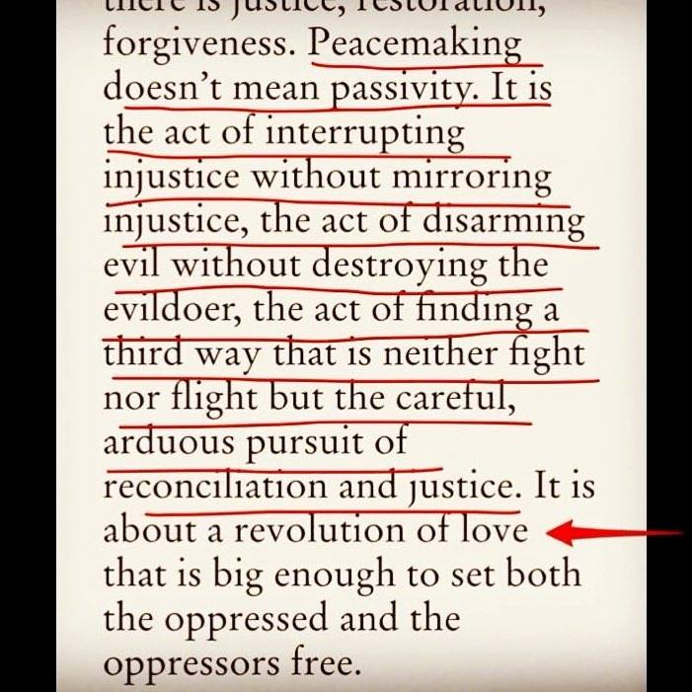

## Sheet to accompany activity 6

**Discussion questions from booklet 6:**

1. How do you understand the economy? What would you want to use as a measure of economic success for society?
2. What are your feelings on having a globalised economy?
3. What words would you use to describe our existing economy?
4. What words would you use to describe the new economy?
5. Is this a useful framework (pg8) for you to think about systems change? What is missing or does it not fit?
6. What does the diagram say to you about power? Where is it held and why?
7. Spend some time thinking about each of these building blocks, which do you feel most connected to and which do you feel unfamiliar with?
8. What is challenging about these five building blocks? How do we prepare ourselves to engage with them?

**Project Planning**

Is your group already at the stage of wanting to take action? If they are, feel free to run through this project plan together or use it as a chance to go away and think about what you’d like to do together as part of the next phase of the new economy project.

**PROJECT NAME** *What will you call this project?*

**VISION** *What will you see as a result of this project achieving its goal?*

**PROJECT DESCRIPTION** *What activities will you engage in that work with how you understand change to happen?*

**NEED AND CONTEXT** *What is your understanding of the problem?*

**PURPOSE**

**PARTNERS + ALLIES** *Who will you work with / need to work with to build power?*

**TEAM –** *Who is committed to doing this work with you?*

**NEXT STEPS –** *What are the first five things you are going to do next ?*

1.

2.

3.

4.

5.

**CHALLENGES** *– what can get in your way that may prevent you doing this work?*